Supplementary material for:
Global warming confers performance advantages to a non-native predator

Future water temperature predictions
To investigate when the selected elevated temperature could be present at the fish collection site, and thus relate the results to the natural thermal conditions, we used available data to simulate the further temperature increase until the end of the century. This was done using the public hydrological data provided by the Institute of Meteorology and Water Management (Instytut Meteorologii i Gospodarki Wodnej) in Poland (https://danepubliczne.imgw.pl/pl/datastore, accessed 15th of April, 2024). We used data for mean daily water temperature in summer (June-August) from Tuchola station, located on the Brda River (53°34'24.0"N 17°54'13.4"E), the closest to the collection site (ca. 50 km in straight line/ca. 65 km upstream), from 1984 to 2009. Further, we fitted a generalised linear models (Gaussian family) separately for each summer month (June–August). Water temperature was included as a dependent variable and year as a fixed explanatory factor.
Based on these models, we predicted mean water temperature in a particular month with their 95% confidence intervals for years 1984-2100. The elevated temperature chosen for the study (23ºC) will be present at fish collection site by the end of the century (Table S1, Figure S1).
Table S1. Generalised linear models summary, examining future water temperature predictions at fish collection site separately for each summer month (June–August). Water temperature was included as a dependent variable and year (1984 – 2009) as a covariate. Significant effect of year was reported by each model (in bold).
Month | Term | F-value | p-value
June | year | 83.568 | <0.001
July | year | 199.86 | <0.001
August | year | 128.32 | <0.001

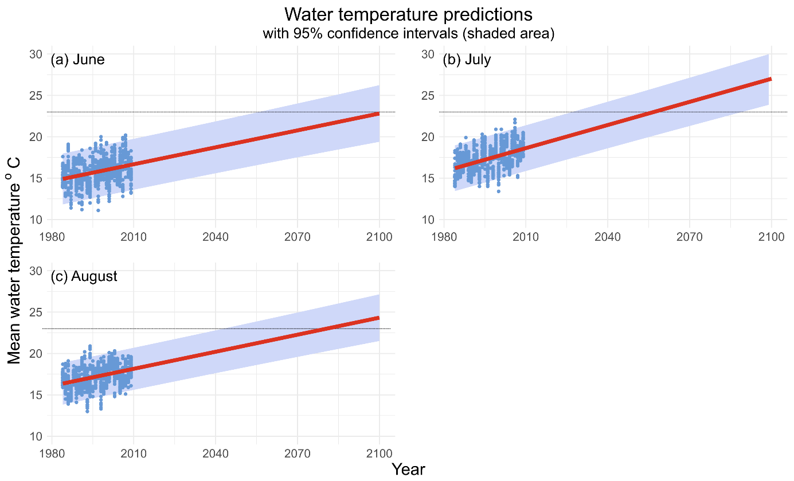
Figure S1. Mean summer water temperature at the fish collection site (Brda River) predicted by the linear regression model by the end of the 21st century. Blue dots represent the daily water temperature values recorded in the 1984-2009 period by the Institute of Meteorology and Water Management (Instytut Meteorologii i Gospodarki Wodnej) in Poland (https://danepubliczne.imgw.pl/pl/datastore, accessed 15th of April, 2024), at Tuchola station (53°34'24.0"N 17°54'13.4"E). Dotted lines represent the temperature used in the study for the warming scenario (23ºC).

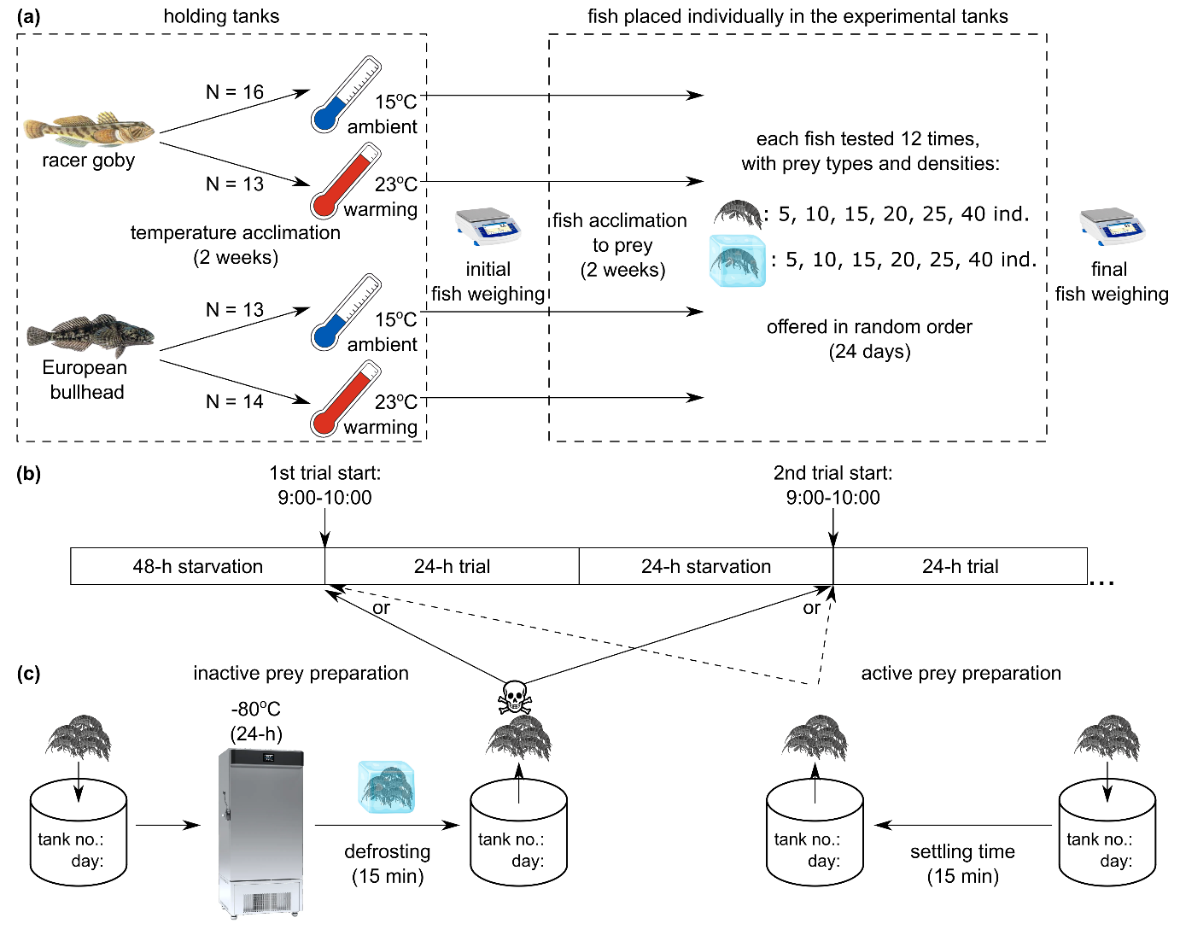
Figure S2. The schematic view of the experimental procedure. (a) Fish handling from capture to the end of the experiment. (b) Order and duration of the various stages of the experiment. (c) Procedure of prey preparation. Note that prey had two weeks to acclimate to the experimental temperature before use and during a single trial a fish received only one type of prey.
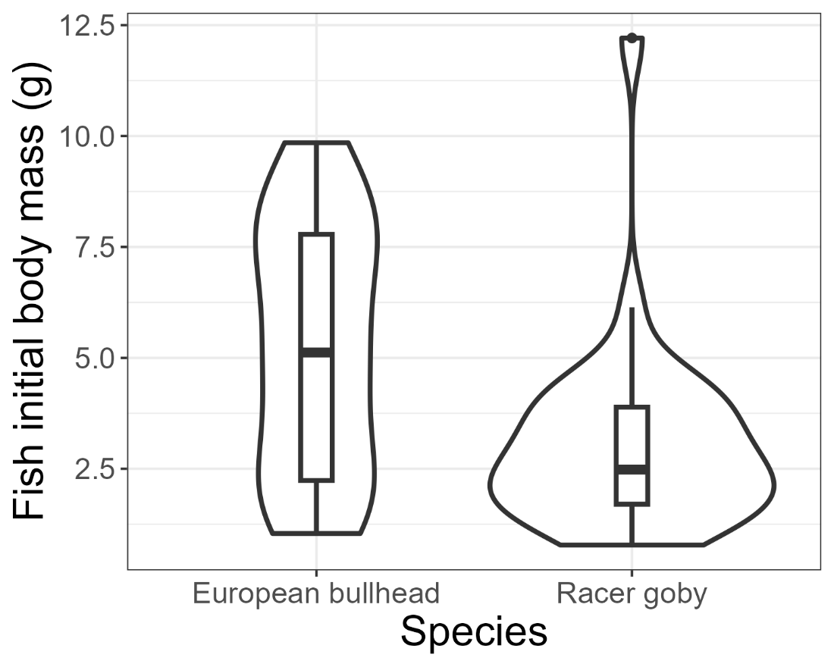
Figure S3. Violin box plots of European bullhead and racer goby body mass. In the boxplots, the horizontal bar displays the median, the box gives the interquartile ranges, and the whiskers show the largest and smallest values up to 1.5 × interquartile range.
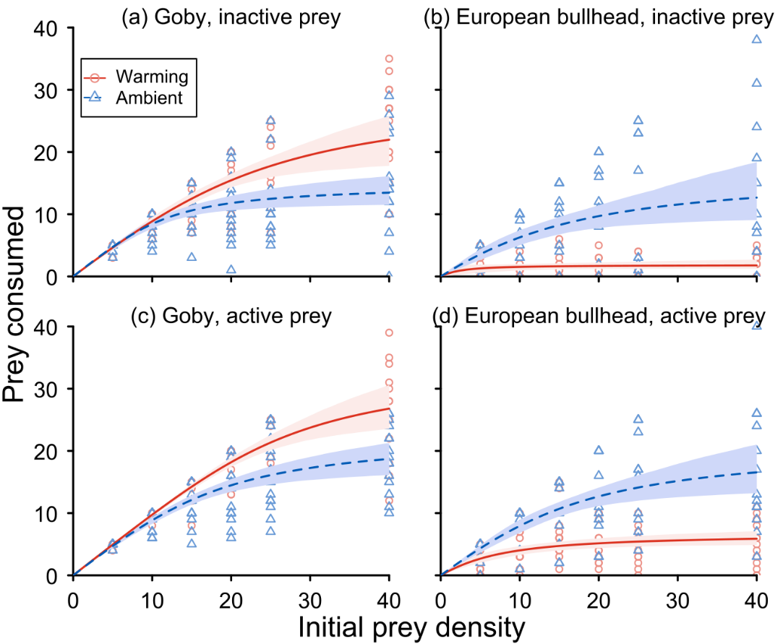
Figure S4. Functional responses between temperature (15, 23 °C) for predator species and prey treatments. Lines are the fits from Rogers random predator equation, points are raw data, and grey areas are 95% non-parametric bootstrapped confidence intervals.
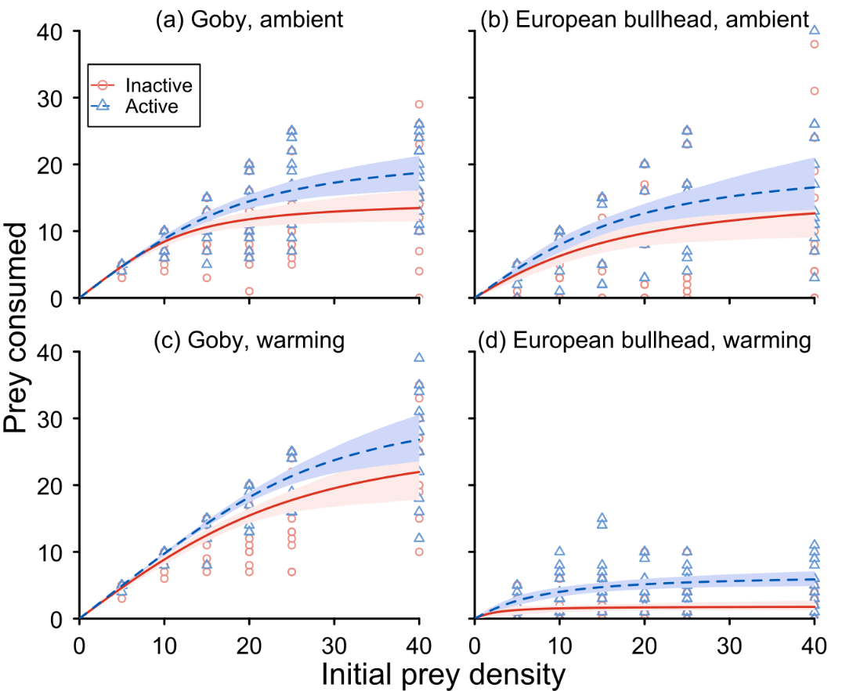
Figure S5. Functional responses between prey type (active, inactive) for predator species and temperature treatments. Lines are the fits from Rogers random predator equation, points are raw data, and grey areas are 95% non-parametric bootstrapped confidence intervals.

