**Abstract**

1. Climate change has a profound impact on ectotherms, which suffer suboptimum thermal conditions in their native areas or spread to previously unavailable locations. However, it is often neglected that responses to environmental changes are likely a population level, rather than species-specific phenomenon.
2. Two groups (Western and Eastern) of the invasive Ponto-Caspian amphipod *Dikerogammarus villosus* independently spread in Europe from isolated, genetically distinct source populations living in the Danube and Dnieper deltas, respectively. They are expected to meet in the near future in Polish inland waters. This makes this species a perfect model to investigate the intraspecific variability in responses to environmental changes, as well as effects of hybridization between different genetic units on invasiveness.
3. We scaled maximal metabolic rate (MMR), standard metabolic rate (SMR), and aerobic scope (AS, a measure of physiological performance) of *D. villo*s*us* at different temperatures and oxygen levels to check differences in responses to environmental changes among the distinct invasive groups and their hybrid.
4. With increasing temperature, the AS scaling exponent of the Western group decreased, whereas AS of the Eastern group was unaffected by temperature. In result, large Western group individuals showed a lower AS at a high temperature, compared to low temperature and to the Eastern group individuals. Oxygen reduction decreased MMR and AS scaling exponents regardless of amphipod group, suggesting that larger individuals experienced a greater reduction in these parameters under low oxygen conditions. Although parental groups reduced their AS in response to oxygen reduction, AS of the hybrid remained stable.
5. In conclusion, organism responses to climate change depend on intraspecific variation, which should be considered in studies related to this topic. Furthermore, *D. villosus* appears sensitive to oxygen deficits and temperature changes (especially the Western group and large individuals), but intraspecific hybridisation can enhance the environmental tolerance of invaders.

Keywords: global warming, ectotherms, metabolic scaling, intraspecific hybridisation, deoxygenation, size spectra, biological invasion, environmental stressors,

**Introduction**

Biological invasions, driven by humans (e.g., globalisation) and accelerated by climate change, pose a significant threat to global biodiversity and cause economic losses estimated at billions of US dollars (Chapman et al., 2020; Diagne et al., 2023; Hudgins et al., 2023; Pysek et al., 2010). To establish a population in a new environment, invaders must overcome a number of barriers related to local abiotic conditions and the resistance of native communities (Atwood & Meyerson, 2011; DeRivera et al., 2005; von Holle & Simberloff, 2005). Introduced populations often exhibit lower genetic and phenotypic diversity than their source populations, potentially limiting their capacity to adapt to non-native environments (Reed & Frankham, 2001). Therefore, increasing the number of propagules and frequency of introduction events can increase the likelihood of a successful establishment of an invasive population (von Holle & Simberloff, 2005).

Genetic diversity and, in consequence, likelihood of a successful invasion can also be increased due to a hybridization with a local population or among invaders from several genetically distinct source populations (van Boheemen et al., 2017; Wu et al., 2015). Intraspecific hybrids may exhibit enhanced genetic pool resulting in phenotypic innovations facilitating their adaptations to new selection pressures from the novel environment. Two non-exclusive mechanisms have been proposed to explain the success of hybrids as invaders: (1) hybrid vigour (heterosis) manifested as higher phenotypic means for some traits in hybrids compared to their parents; and (2) high genetic and phenotypic variance increasing the ability to adapt to new environments (Ellstrand & Schierenbeck, 2000; Facon et al., 2005). Invasive hybrids have the potential to outperform their parents in terms of fecundity, juvenile size, growth rate, locomotory abilities, or environmental tolerance (Bakhmet et al., 2022; Facon et al., 2005; Johnson et al., 2010; Wang & Liu, 2022). As a result, hybrids may replace pure parental genotypes in the environment, may have a greater impact on the invaded community, and even spread to habitats previously unavailable to their parents (Mesgarana et al., 2016; Pierce et al., 2017; San Jose et al., 2023).

The Ponto-Caspian alien species particularly threaten freshwater and brackish ecosystems in Central and Western Europe. They have evolved in environments with frequent fluctuations in several environmental factors, including water level, salinity, and temperature (Bij de Vaate et al., 2002; Cristescu et al., 2004), which enhanced their phenotypic plasticity and finally made them successful invaders (Balzani et al., 2022; Bij de Vaate et al., 2002; Grabowski et al., 2009; Leuven et al., 2009). The Ponto-Caspian fauna can use three migratory routes (corridors) in Europe (Bij de Vaate et al., 2002), which may transfer geographically isolated and genetically distinct source populations to new areas (Rewicz et al., 2015). Due to unique genetic resources, each transferred population has a specific set of biological traits that shape its interaction with local biota and determine environmental tolerance (Hupało et al., 2018; Podwysocki et al., 2024). Therefore, analyses based on individuals belonging to a single invasion event or a single invasive lineage may underestimate the true invasive potential of the species.

Among the Ponto-Caspian invaders in Europe, the amphipod *Dikerogammarus villosus* demonstrates one of the highest invasive potentials (Rewicz et al., 2014; Soto et al., 2023). *Dikerogammarus villosus* is an omnivorous species that exhibits a wide range of thermal and salinity tolerance (Bruijs et al., 2001; Cuthbert et al., 2020; Rewicz et al., 2014) and outperforms other amphipods in growth rate and fecundity (Grabowski et al., 2007; Pöckl, 2009). Therefore, the presence of this invader generates a fast and deep change in the local community structure and functionality (Dick et al., 2002; Dick & Platvoet, 2000; Platvoet et al., 2009; van Riel et al., 2006). Two source populations in the native range, one from the Danube Delta and the other from the Dnieper Delta, constitute two genetically distinct, independent sources for the invasion of this species in Europe (Rewicz et al., 2015). These two independent invasive groups (hereafter referred to as the Western and Eastern group, respectively) are present in large rivers in Poland. The Eastern group moved from the Dnieper Delta using the central corridor (Bij de Vaate et al., 2002), the part of which is the River Vistula. The Western group moved from the Danube Delta upstream the River Danube through the southern corridor to western Europe, down to the River Rhine delta. Then, it migrated back eastwards, through Mittelland Canal, entering the River Oder in western Poland (Rewicz et al., 2015). A meeting of these groups outside their native range is highly probable, as their current locations (the catchments of the Vistula and Oder Rivers, respectively) are connected by an artificial “Bydgoski Canal” and the distance between their current ranges is less than 150 km (Figure 1). Therefore, the appearance of an intraspecific hybrid in the contact zone is probable. Due to their higher genetic variance, the hybrid may exhibit even higher invasive potential than its parents leading to a “re-invasion” of inland waters by more invasive hybrid individuals.

Metabolism is fundamental for animal growth, reproduction and behaviour (Crespel et al., 2024; Glazier et al., 2020; Glazier & Gjoni, 2024). In aquatic ectotherms, metabolic performance is strongly linked to environmental conditions including oxygen concentration and temperature (Gjoni et al., 2020, 2024; Rubalcaba et al., 2020). Thus, increases in temperature and deoxygenation of aquatic habitats caused by global warming have a profound impact on aquatic communities (Marszelewski et al., 2022; Zhi et al., 2023). In this study, we examined body-mass scaling of three metabolic parameters: maximum metabolic rate (MMR, representing the maximum efficiency of aerobic metabolism), standard metabolic rate (SMR, the minimum metabolic rate required to maintain basic physiological processes), and aerobic scope (AS, representing the capacity of an organism to fuel its oxygen-consuming activity above its basic maintenance requirements) of *D. villosus* from the Western and Eastern groups, as well as their hybrids, under varying oxygen and temperature conditions.

The first question addressed by our study is whether the distinct invasive groups of *D. villosus* exhibit different metabolic responses to environmental change (here: temperature and oxygen conditions). Such intraspecific genetic diversity may contribute to differences in the invasive species performance at various invaded locations, as well as shape the current and future spread of the species, and its particular populations. The second question is whether intraspecific hybridisation may help the invader cope even better with increasing temperature and limited oxygen. As global warming progresses, animals encounter suboptimal conditions that may hinder their ecological success, including their potential for successful invasion. Intraspecific hybridisation, which increases genetic and phenotypic variance, can contribute to the success of an alien species in coping with the consequences of climate change.

**Material and methods**

To answer these questions, we conducted two experiments on two sets of amphipods. The first set consisted of individuals collected from rivers invaded by the two groups (Western and Eastern) of *D. villosus* (details in section “a” below). Measurements conducted on genetically distinct wild populations demonstrate the combination of the effects of genetic resources unique to each lineage with modifying environmental factors present at each location. We assessed the impact of thermal and oxygen concentration changes on the metabolic scaling of these populations, exposing them to different oxygen and temperature conditions (details below).

To assess the impact of hybridisation on environmental tolerance, we used the second set of individuals: we bred the two invasive amphipod groups, separately or mixed, in a mesocosm culture to obtain offspring belonging genetically to one of the two pure invasive groups, or their hybrids, respectively. Then, we compared the metabolic scaling relationships under varying oxygen conditions between the hybrid and pure parental groups (see section “b” below for details). Mesocosm amphipods have been bred and reared under the same conditions, without the pressure of predation, interspecific competition, or food limitation. Measurements on these individuals allowed us to illustrate the effects of genetic distinctness between the groups and hybridisation between them on metabolic scaling, unaffected by specific environmental conditions in the two rivers from which the parental populations were sampled. Due to limitations in the number of available individuals obtained from the mesocosm breeding, this group of amphipods was only exposed to varying oxygen levels at a constant temperature. *Dikerogammarus villosus* has been previously found to become relatively sensitive to changes in temperature when oxygen is limited (Verberk et al., 2018). Therefore, we focused on this aspect of the hybrid performance, as it has the greatest potential to make up for the current weakness of this invader.

**(a) Experiment I: impact of varying oxygen and temperature conditions on the metabolic scaling of the wild invasive amphipod groups**

Individuals of *D. villosus* (body mass range: 0.012-0.190 g) were collected in spring 2022 in Poland at two locations in the River Oder (Western group): Brzeg (50° 51' 37.8'' N, 17° 27' 59.399''E) and Zdzieszowice (50° 24' 42.12'' N, 18° 6' 25.559'' E) and two locations in the River Vistula (Eastern group): Wyszogród (52° 23’ 4.56’’ N, 20° 11' 31.2'' E) and Ciechocinek (52° 52' 52.68'' N, 18° 50' 0.6'' E) (Figure 1). We sampled different locations within each river to reduce the effect of river-specific environmental conditions on amphipod responses. In 2022, we measured conductivity and pH regularly (once a month) at each site (Table 1) to control for abiotic factors that may affect amphipod metabolism. In addition, using data from a public repository of the Institute of Meteorology and Water Management in Poland (https://danepubliczne.imgw.pl/data/dane_pomiarowo_obserwacyjne/), we studied long-term changes in annual and maximal summer water temperatures in the Vistula (measured at Wyszogród: 52°23'07.1"N 20°11'37.8"E and Kępa Polska 52°25'52.7"N 19°57'47.8"E stations, data available for 1984-2022 period) and Oder (Brzeg: 50°51'56.2"N 17°28'08.8"E and Ścinawa: 51°24'31.4"N 16°26'36.7"E stations, 1984-2014) rivers (Figure 1A and 1B supplementary materials). Selected stations are located in close proximity to the amphipod collection area. After collection, we transported amphipods to an air-conditioned room and gradually (1 oC per day) acclimatised them to the temperatures used during the metabolic measurement (15 oC or 25 oC). These temperatures reflected natural, non-stressed thermal conditions in the rivers (15 oC), as well as thermal conditions that occur during present heat events (25 oC) in major European rivers including amphipods sampling sites (Figure 1B supplementary materials). Such events are predicted to become more frequent and prolonged in the future (Marszelewski et al., 2022). During two weeks of acclimation, each group was kept in separate aerated tanks with stones and artificial plants as shelters. Amphipods were fed daily with frozen chironomids and dried birch leaves. After the acclimation, amphipods were transferred to respirometry systems to assess their oxygen consumption (details in section “c” below). Additionally, during the measurements, amphipods were exposed to two oxygen concentration treatments: saturated (9.5 or 7.5 mg/l at a temperature of 15 and 25 oC, respectively, corresponding to 95% saturation at these temperatures) or reduced (5.5 mg/l at both temperatures).

**(b) Experiment II: impact of oxygen limitation on metabolic scaling of the F1 generation of amphipods bred in the mesocosm culture: two pure groups and their intraspecific hybrid**

F1 generations of the pure groups and their hybrid (body mass range: 0.024-0.172 g) were obtained in an outdoor mesocosm breeding system located in Lutomiersk, Poland (51°44'00.7"N; 19°13'02.0"E). The system consisted of nine roofed outdoor tanks, each of a volume of 700 L. The mesocosm system was open (i.e., no walls), thus the thermal and light conditions in the system reflected natural fluctuations in the field during the reproduction period. Filtered and UV-sterilised water from a local pond was used to fill and exchange water in the tanks (10-15% per day). Water in the tanks was continuously aerated. Pebbles and decomposing leaves were used to create shelters at the bottom of the tanks. The tanks were divided into three groups (three tanks in each), containing:

1. pure Eastern group i.e., males and females from the River Vistula
2. pure Western group i.e., males and females from the River Oder
3. Females from the Eastern group and males from the Western group to obtain hybrid offspring (due to space limitations, we skipped the opposite mixed configuration)

On the 11-12th of April, 2022, amphipods were collected from the same locations as described in section “a”. Individuals were sorted for males and females and put in temporary tanks for around 30 days to be sure that ovigerous females lost their breed. Then, on the 13th of May, 2022, 132 females and 96 males were introduced to each mesocosm tank. Individuals collected at different locations of the same river were pooled in equal numbers to obtain three final groups: one pure population from each group and a mixed group to produce hybrids. Amphipods were fed daily with live chironomid larvae. Abiotic parameters in the mesocosms were controlled regularly (Table 2). At the end of September, F1 individuals (two pure parental groups and one hybrid) were collected from the mesocosm tanks, transported to the laboratory, and gradually (1 oC per day) acclimated to 15 oC. Following two weeks of acclimation, amphipods were transferred to respirometry systems to assess their oxygen consumption (details in section "c").

**(c) Respirometry measurements of wild and mesocosm-bred amphipods**

Before being placed in respirometry chambers, amphipods from all groups were isolated in 100 ml containers and fasted for 24 h according to the protocol by (Gjoni et al., (2020). Each amphipod was then subject to an exercise test with a magnetic stirrer, where the water current and an experimenter using a stick stimulated the animal to swim actively. The water parameters (temperature and oxygen) during the exercise test reflected the conditions during the subsequent respirometry measurement. The temperature was the same as during the acclimation preceding the measurements. When the amphipod exhibited complete exhaustion (indicated by passive drifting and lack of response to a touch of the stick), it was placed in an individual respiration chamber for 4 h.

Amphipod oxygen consumption was measured using intermittent flow-through respirometry. Each respirometry set (one of five) comprised four borosilicate glass chambers (inner diameter: 7 mm; length: 20 mm) submerged in a 120-L aquarium. Water mixing inside the chambers was achieved using a custom-built peristaltic pump with four channels, which moved water through the chambers via gas transmission-resistant tubes (VERSILON C-210A, Saint Gobain Performance Plastics, France). The concentration of oxygen inside the chamber was monitored every 5 s using 4-channel oxygen meters (OXY-4 SMA G3, PreSens - Precision Sensing GmbH, Germany) connected to oxygen sensors (O2 Flow-Through Cell FTC-PSt7, PreSens - Precision Sensing GmbH, Germany) located on the tubes connecting the chambers to the peristaltic pump. The chambers were rinsed with aerated water from the aquarium for one minute using an automatic water flushing pump at 4-minute intervals. The total volume of the single circuit (the chamber and tubes) was 18 ml.

To achieve a reduced oxygen concentration, we used a system consisting of an oxygen sensor (Oxygen mini, OxyGuard International, Denmark) and a programmable LED indicator (PR 5714, PR Electronics) to control a solenoid valve. The solenoid valve, when open, pumped nitrogen into the aquarium to remove oxygen from the water. The concentration of oxygen in the water was 9.5 ± 0.1 mg/l at 15°C and 7.5 ± 0.1 mg/l at 25°C when the nitrogen dosing system was inactive. When the system was activated, the concentration of oxygen was 5.5 ± 0.1 mg/l at both temperatures.

The water temperature in the aquaria was regulated using an aquarium cooler/heater (TK 500, TecoUS, Italy) connected to an external thermo-regulator (Ringder DTC-120), which maintained temperature fluctuations at 0.1 oC. Additionally, the water inside the aquaria was continuously sterilised using a UV sterilizer (UV Reeflex 500, EHEIM, Germany) to reduce microbial respiration. To estimate the background oxygen consumption during respirometric measurements, an empty chamber was randomly selected from the four chambers connected to the peristaltic pump and submerged in the same aquarium.

The final two minutes of each 4-minute interval starting after the chamber's water renewal were used to analyse the animal's oxygen consumption. To eliminate the effect of microbial oxygen consumption, the oxygen decrease in the empty chamber (no amphipod) during each interval was subtracted from the values measured during parallel periods in the chambers with amphipods from the same aquarium.

The maximum oxygen uptake during the first four intervals of the exposure was considered to reflect the maximum metabolic rate (MMR). The oxygen uptake during the remaining period was used to calculate the standard metabolic rate (SMR) (the lowest 10th percentile of measurements taken throughout the measurement period). Aerobic scope (AS) was calculated by subtracting SMR from MMR. The total time of oxygen consumption measurement was 4 h. We estimated this time based on a preliminary test, which showed that the value of the SMR calculated from a 4 h period was not different from the value obtained from a 24 h period, indicating that amphipods calmed down relatively quickly after the exhaustion test. After 4 h of oxygen consumption measurement, amphipods were gently removed from the chambers onto a sieve, dried on a paper towel, and weighed with accuracy to 0.1 mg (Radwag AS 110/C/2 laboratory scales, Radom, Poland).

**Data analysis**

***Temperature***

To analyse summer temperatures at amphipod collection sites we applied General Linear Mixed Model (GLMM) with a Gaussian distribution, with River (Vistula or Oder) as a categorical factor, Station (Wyszogród, Kepa Polska, Brzeg and Ścinawa) as random factor (nested within River) and Year as a continuous covariate and interaction between them.

***Experiment I (metabolic scaling of the wild invasive amphipod groups)***

To analyse factors affecting the response of the wild *D. villosus* groups (MMR, SMR and AS) to different temperature and oxygen conditions, we applied General Linear Mixed Models (GLMMs) with a Gaussian distribution, with Temperature (15 or 25 oC), Oxygen condition (saturated or reduced), and Amphipod group (Western or Eastern) as categorical factors, and Body mass as a continuous covariate, using lme4 package (Bates et al., 2015). We also included the amphipod Collection site as a random factor (nested within Group) to control for the potential effect of local river conditions on the amphipod response. For AS, due to the variance of the random effect estimated as 0, we applied a General Linear Model with a Gaussian distribution including Oxygen condition and Amphipod group as categorical factors, and Body mass as a continuous covariate.

***Experiment II (metabolic scaling of the pure groups and their intraspecific hybrids bred in the mesocosm culture)***

To analyse factors affecting responses (MMR, SMR and AS) of the F1 generation of amphipods from the mesocosm culture, we applied a GLM with Gaussian distribution, with Oxygen condition (saturated or reduced) and Treatment (pure Western group, pure Eastern group or hybrid) as categorical factors, and Body mass as a continuous covariate.

***General remarks***

We log10-transformed amphipod body mass, MMR, SMR, and AS to linearize relationships between the metabolic rate and mass. All analyses were carried out using R 4.3.3 (R Core Team, 2024).

For all analyses, we started with the full factorial models, which were further simplified by deleting the highest-order non-significant interaction terms. We retained the more complex model when its AICc (AIC corrected for small sample sizes) value was lower than that of the simpler model by 2 or more (Burnham & Anderson, 2004). We checked model assumptions by visual inspection of residual plots. For significant effects of the categorical factors and their interactions, we compared means between groups. For significant interactions of Body mass with other factors, we first compared slopes between the regression lines. When the slopes did not differ significantly, we further compared means between the groups. All post-hoc tests were performed using Fisher's least significant difference (LSD) pairwise comparisons with sequential Bonferroni corrected p-values, in emmeans package (Lenth R, 2024). Graphs were prepared using ggplot2 package (Wickham, 2016).

**Results**

***Experiment I (metabolic scaling of the wild invasive amphipod groups)***

Maximum metabolic rate (MMR) scaling with Body mass depended on Oxygen concentration, but not on Temperature or Amphipod group (Table 3). The slope of MMR scaling was significantly steeper at saturated versus reduced oxygen concentration, with the largest individuals exhibiting higher MMR at saturated vs low oxygen conditions (Figure 2, p = 0.005). Moreover, MMR was constantly (across the entire range of Body mass) elevated at 25 oC versus 15 oC (Figure 3, p < 0.001).

Standard metabolic rate (SMR) depended on an Oxygen * Temperature interaction across the entire range of Body mass, independent of Amphipod group (Table 3). At 15 oC, SMR was higher at the saturated versus reduced oxygen concentration (p < 0.001), whereas no differences in SMR between the two oxygen treatments were observed at 25 oC (Figure 4). SMR was higher at 25 oC versus 15 oC at both oxygen concentrations (Figure 4, p < 0.001).

Aerobic scope (AS) scaling with Body mass varied with Lineage and Temperature, as well as with the Oxygen concentration (Table 3). The AS scaling slope of amphipods of the Western group was shallower at 25 oC than at 15 oC (Figure 5, p = 0.023), as well as than that of the Eastern group at 25 oC (Figure 5, p = 0.031). These differences resulted from the fact that at 25 oC, large Western group individuals exhibited a reduced AS compared to the other groups. By contrast, AS value of Eastern group amphipods did not differ in slopes or intercepts between the temperatures. At 15 oC, we did not observe differences in slopes and intercepts between the amphipods from both groups (Figure 5). Moreover, AS scaling with Body mass was steeper at the saturated versus reduced oxygen concentration (Figure 6, p = 0.038).

***Experiment II (metabolic scaling of the pure groups and their intraspecific hybrids bred in the mesocosm culture)***

Maximum metabolic rate was significantly higher at the saturated versus reduced oxygen concentration (p = 0.025) across the entire range of Body mass, with no differences between the F1 animals of different groups (Table 4, Figure 7). On the other hand, SMR depended on Treatment (Table 4). SMR shown by the pure Eastern group individuals of the F1 generation was higher than that exhibited by the hybrid amphipods (Figure 8, p = 0.024). AS depended on the Treatment * Oxygen conditions interaction (Table 4). The AS shown by both pure groups was lower at the reduced vs saturated oxygen concentration (p < 0.001 for the Western group, p = 0.003 for the Eastern group), whereas the AS of the hybrid amphipods was independent of Oxygen conditions (Figure 9). At saturated oxygen conditions, AS was similar between all the treatments, whereas at reduced oxygen concentration, the hybrid amphipods showed significantly higher AS compared to that of the Western group (Figure 9, p = 0.003).

**Discussion**

Our work reveals that two genetically distinct amphipod groups from separate source populations exhibit different AS modifications in response to increasing temperature. Higher AS allows animals to invest more energy in oxygen-consuming activities, such as movement, digestion, growth or reproduction (Brandl et al., 2023). At 15 °C, the AS value did not differ between the amphipod groups. However, with increasing temperature, we observed metabolic changes that made the AS slope of Eastern group amphipods significantly steeper than that showed by Western group individuals, thus pointing to an advantage of large Eastern group individuals in this parameter. Eastern group individuals were found to invest more resources into cellular defence under thermal stress (Hupało et al., 2018), but, according to our current results, they still have higher AS, which points to their higher resistance: they can defend more efficiently against heat and even then have more energetic resources for key oxygen consuming activities. Observed physiological differences in thermal sensitivity may result from group-specific genetic resources determining the ability of amphipods to cope with an increased temperature. They could be shaped by thermal conditions in their native regions, along their migration routes and/or in currently inhabited areas. Amphipods belonging to the Western group have come from the Danube Delta, characterised by higher annual temperature than the Dnieper Delta, the native region of the Eastern group (Tockner et al., 2009). During their migration, they were under pressure of corridor-specific conditions, i.e. harsher continental climate with lower mean annual temperatures in Central Europe, compared to the southern corridor shaped by Mediterranean and Atlantic climate (Hupało et al., 2018). At the collection sites, invasive amphipods have experienced a lower mean annual temperature in the Vistula River than in the Oder River, both belonging to the central corridor. However, summer maximal temperature is higher in the Vistula River than in the Oder River, indicating the higher annual amplitude in the former location (Supplementary material, Figure 1A and 1B). Thus, our study suggests that conditions recently experienced by the amphipods at the collection sites were the most important for determining their resistance, as the Eastern group amphipods, experiencing higher maximum annual temperatures in the Vistula River, performed better at a high experimental temperature. Nevertheless, our study showed that invasive potential and capacity to deal with climate change differ among various populations of the same species. Accordingly, long-term predictions based on a single population or individuals belonging to the same genetic group may underestimate the response of the representatives of the entire species. For example, the long-term forecast of thermal mortality of *D. villosus* is based on the study conducted only on the Western group (Verberk et al., 2023), which, according to our observations, is less thermotolerant than the Eastern group. Thus, we highlight the importance of considering intraspecific variability when assessing invasive species potential or predicting the consequences of climate change.

Regardless of lineage identity, metabolic parameters of *D. villosus* were temperature and, especially, oxygen-sensitive, as indicated by lower MMR and AS at the reduced vs saturated oxygen concentration shown by large (Experiment I) or all (Experiment II) amphipods. MMR represents the highest amount of oxygen that individuals can uptake from environment and is a key component of AS. Analysis of MMR and AS scaling relationships of the field-collected individuals (Experiment I) indicates that the metabolism of larger individuals relies on oxygen to a greater extent than that of smaller animals. This finding corroborates a meta-analysis of fish metabolic rates, which demonstrated that oxygen limitation is more likely to restrict metabolism in larger individuals (Rubalcaba et al., 2020). This is because larger specimens suffer a reduced ability to uptake oxygen from the environment (Verberk et al., 2021). Metabolic sensitivity of *D. villosus,* especially large individuals, to oxygen limitation may explain its occurrence in the nearshore zone of rivers and dam reservoirs, close to the water line, where water dynamics provides good oxygen saturation (Borza et al., 2017; Verberk et al., 2018). Various factors, such as water dynamics and stratification, decomposition processes, salinity, eutrophication, and temperature influence the concentration of oxygen in water. The amount of dissolved oxygen in water decreases due to ongoing global warming and anthropogenic pressure (Missaghi et al., 2017; Rajesh & Rehana, 2022; Zhi et al., 2023). Consequences of progressing deoxygenation in aquatic habitats are already evident. For instance, oxygen limitation negatively affected distribution of nymphs of native mayfly species in UK streams (Verberk et al., 2016). Accordingly, we predict that the future occurrence of *D. villosus,* one of the most dangerous aquatic invasive invertebrates in Europe, may be rebuilt due to water deoxygenation. Among native and non-native amphipods, *D. villosus* reaches one of the largest body sizes, which provides it with an advantage in competition and predation (Taylor & Dunn, 2017). However, higher sensitivity of larger *D. villosus* individuals to water deoxygenation, indicated by the observed MMR and AS modifications, may negatively affect its size structure. The consequences of the reduction in size can be visible in a number of dimensions. The largest individuals exhibit the strongest environmental effects, as predators, competitors, and shredders of the thick detritus. Moreover, a change in size structure can be manifested in the reproductive effort. The reproductive capacity of ectothermic organisms is positively related to their body size (Naranji et al., 2021). Elimination of the most fertile females may reduce reproductive capacity, leading to a reduction in population size. Thus, the impact of the invasive amphipod on local communities would be reduced not only as a result of its smaller size but also due to the lower density.

The mesocosm-bred individuals of the pure parental groups showed oxygen-sensitive MMR and AS. On the other hand, the AS of the intraspecific hybrid was insensitive to changes in oxygen concentration. Previous studies highlighted the significance of oxygen for the thermal tolerance of *D. villosus* (Verberk et al., 2018). Our study demonstrates that intraspecific hybridisation would reduce the sensitivity of *D. villosus* to oxygen deficits. Such an increased tolerance to oxygen deficits in hybrids may have several implications. First, due to their higher hypoxia tolerance, hybrids may colonise habitats previously unavailable to parental populations or still thrive in environments affected by global warming (Lucek et al., 2010; Rius & Darling, 2014; Roy et al., 2015). Second, as the intensity of extreme environmental events is predicted to increase due to ongoing climate change, amphipod populations enriched by inter-lineage hybrids, being more tolerant to oxygen deficiency, may be more successful in the invasion process under global warming scenarios compared to pure parental lineages. Third, due to undisturbed AS, the environmental pressure on larger hybrid animals may decrease and, as a consequence, hybrids may grow faster and reach larger body sizes than their parents. Even if parental populations are limited by oxygen deficits, the hybrids may continue to exert invasive pressure on the local community. Notably, the F1 individuals used in the present study have half of their genes from each invasion group. It is likely that phenotypes with even higher environmental tolerance than the F1 hybrid individuals tested here may appear due to progressive population mixing, introgression, and natural selection. It should be noted that thermotolerance, i.e. advantage of the Eastern group over the Western one, and advantage of their intraspecific hybrid over both parental groups, is expected to increase its importance in the future, given the ongoing warming trend observed in both river systems inhabited by *D. villosus*, which is particularly strongly manifested in summer (Sun et al., 2024; Zhou et al., 2024). This is likely to lead to profound genetic and phenotypic changes in invasive populations, potentially resulting in changes in their impact and functioning.

Despite having the same genetic material, amphipods collected from rivers and those reared in mesocosms differ from each other in metabolic scaling response. In wild populations, oxygen limitation mainly affected the MMR and AS of large individuals, whereas in mesocosm individuals such a response was seen across the whole range of body mass. In contrast to natural conditions, amphipods in the mesocosms grew without pressure from predators, competitors other than conspecifics, or food limitation. This is evidence that metabolic rate is a plastic trait, shaped by complex interactions between multiple environmental factors.

According to experimental (Brauer et al., 2023) and simulation studies (Kulmuni et al., 2024), hybridisation facilitates adaptation to rapid environmental changes, thus, making animals less vulnerable to the effects of climate change. However, not all hybrids display a greater environmental tolerance than their parental populations. For instance, a hybrid of two sister species of marine tunicates (*Pyura herdmani* and *Pyura stolonifera*) showed lower performance than the parental species when exposed to an increased temperature (Hudson et al., 2021). It should also be noted that a higher environmental tolerance resulting from hybridisation may be associated with weaknesses in other areas of physiology, behaviour, or interactions with other species. Our study is the first experimental test of the metabolism rate of intraspecific hybrids of *D. villosus*. Currently, our understanding of physiology and behaviour of these hybrids is still limited. Therefore, further studies are necessary to evaluate their full invasive potential.

In conclusion, our study of invasive lineages of a Ponto-Caspian amphipod shows that the effects of global warming may vary between genetically distinct populations. Differences in thermal sensitivity between lineages may determine their future distribution and interactions with native communities. Therefore, predictions of the consequences of climate change on animal distributions should consider intraspecific differences. Additionally, our research indicates that, among the environmental factors altered by climate change, oxygen depletion is likely to play a crucial role in shaping the metabolic response of animals. Finally, we found evidence that intraspecific hybridisation due to relocations of organisms from different source populations to the same new areas may aid organisms in adapting to climate change. This emphasizes that biological invasions are a population-level, rather than a species-specific phenomenon (Haubrock et al., 2024; Sousa et al., 2024). Accordingly, an introduction of conspecifics from another population to a location already inhabited by a given species may considerably change the performance of the local population, including its ability to spread and survive environmental stress.

Literature

Atwood, J., & Meyerson, L. (2011). Beyond EICA: understanding post-establishment evolution requires a broader evaluation of potential selection pressures. *NeoBiota*, *10*, 7–25. https://doi.org/10.3897/neobiota.10.954

Bakhmet, I., Aristov, D., Marchenko, J., & Nikolaev, K. (2022). Handling the heat: Changes in the heart rate of two congeneric blue mussel species and their hybrids in response to water temperature. *Journal of Sea Research*, *185*. https://doi.org/10.1016/j.seares.2022.102218

Balzani, P., Cuthbert, R. N., Briski, E., Galil, B., Castellanos-Galindo, G. A., Kouba, A., Kourantidou, M., Leung, B., Soto, I., & Haubrock, P. J. (2022). Knowledge needs in economic costs of invasive species facilitated by canalisation. *NeoBiota*, *78*, 207–223. https://doi.org/10.3897/NEOBIOTA.78.95050

Bates, D., Mächler, M., Bolker, B., & Walker, S. (2015). Fitting Linear Mixed-Effects Models Using **lme4**. *Journal of Statistical Software*, *67*(1). https://doi.org/10.18637/jss.v067.i01

Bij de Vaate, A., Jazdzewski, K., Ketelaars, H. A. M. M., Gollasch, S., van der Velde, G., Jażdżewski, K., Ketelaars, H. A. M. M., Gollasch, S., & van der Velde, G. (2002). Geographical patterns in range extension of Ponto-Caspian macroinvertebrate species in Europe. *Canadian Journal of Fisheries and Aquatic Sciences*, *1174*(7), 1159–1174. https://doi.org/10.1139/f02-098

Borza, P., Huber, T., Leitner, P., Remund, N., & Graf, W. (2017). Current velocity shapes co-existence patterns among invasive *Dikerogammarus species*. *Freshwater Biology*, *62*(2), 317–328. https://doi.org/10.1111/fwb.12869

Brandl, S. J., Lefcheck, J. S., Bates, A. E., Rasher, D. B., & Norin, T. (2023). Can metabolic traits explain animal community assembly and functioning? *Biological Reviews*, *98*(1), 1–18. https://doi.org/10.1111/brv.12892

Brauer, C. J., Sandoval-Castillo, J., Gates, K., Hammer, M. P., Unmack, P. J., Bernatchez, L., & Beheregaray, L. B. (2023). Natural hybridization reduces vulnerability to climate change. *Nature Climate Change*, *13*(3), 282–289. https://doi.org/10.1038/s41558-022-01585-1

Burnham, K. P., & Anderson, D. R. (Eds.). (2004). *Model Selection and Multimodel Inference*. Springer New York. https://doi.org/10.1007/b97636

Chapman, D. S., Gunn, I. D. M., Pringle, H. E. K., Siriwardena, G. M., Taylor, P., Thackeray, S. J., Willby, N. J., & Carvalho, L. (2020). Invasion of freshwater ecosystems is promoted by network connectivity to hotspots of human activity. *Global Ecology and Biogeography*, *29*(4), 645–655. https://doi.org/10.1111/geb.13051

Crespel, A., Lindström, J., Elmer, K. R., & Killen, S. S. (2024). Evolutionary relationships between metabolism and behaviour require genetic correlations. In *Philosophical transactions of the Royal Society of London. Series B, Biological sciences* (Vol. 379, Issue 1896, p. 20220481). https://doi.org/10.1098/rstb.2022.0481

Cristescu, M. E. A., Witt, J. D. S., Grigorovich, I. A., Hebert, P. D. N., & MacIsaac, H. J. (2004). Dispersal of the Ponto-Caspian amphipod *Echinogammarus ischnus*: invasion waves from the Pleistocene to the present. *Heredity*, *92*(3), 197–203. https://doi.org/10.1038/sj.hdy.6800395

Cuthbert, R. N., Kotronaki, S. G., Dick, J. T. A., & Briski, E. (2020). Salinity tolerance and geographical origin predict global alien amphipod invasions. *Biology Letters*, *16*(9). https://doi.org/10.1098/rsbl.2020.0354

DeRivera, C. E., Ruiz, G. M., Hines, A. H., & Jivoff, P. (2005). Biotic resistance to invasion: Native predator limits abundance and distribution of an introduced crab. *Ecology*, *86*(12), 3364–3376. https://doi.org/10.1890/05-0479

Diagne, C., Ballesteros-Mejia, L., Cuthbert, R. N., Bodey, T. W., Fantle-Lepczyk, J., Angulo, E., Bang, A., Dobigny, G., & Courchamp, F. (2023). Economic costs of invasive rodents worldwide: the tip of the iceberg. *PeerJ*, *11*, e14935. https://doi.org/10.7717/peerj.14935

Dick, J. T. A., & Platvoet, D. (2000). Invading predatory crustacean *Dikerogammarus villosus* eliminates both native and exotic species. *Proceedings of the Royal Society B: Biological Sciences*, *267*(1447), 977–983. https://doi.org/10.1098/rspb.2000.1099

Dick, J. T. A., Platvoet, D., & Kelly, D. W. (2002). Predatory impact of the freshwater invader *Dikerogammarus villosus* (Crustacea: Amphipoda). *Canadian Journal of Fisheries and Aquatic Sciences*, *59*(6), 1078–1084. https://doi.org/10.1139/f02-074

Ellstrand, N. C., & Schierenbeck, K. A. (2000). Hybridization as a stimulus for the evolution of invasiveness in plants? *Proceedings of the National Academy of Sciences*, *97*(13), 7043–7050. https://doi.org/10.1073/pnas.97.13.7043

Facon, B., Jarne, P., Pointier, J. P., & David, P. (2005). Hybridization and invasiveness in the freshwater snail *Melanoides tuberculata*: Hybrid vigour is more important than increase in genetic variance. *Journal of Evolutionary Biology*, *18*(3), 524–535. https://doi.org/10.1111/j.1420-9101.2005.00887.x

Gjoni, V., Basset, A., & Glazier, D. S. (2020). Temperature and predator cues interactively affect ontogenetic metabolic scaling of aquatic amphipods. *Biology Letters*, *16*(7), 20200267. https://doi.org/10.1098/rsbl.2020.0267

Gjoni, V., Marchessaux, G., Glazier, D. S., Wesner, J. S., Bosch-Belmar, M., Mancuso, F. P., Tantillo, M. F., Marsiglia, N., & Sarà, G. (2024). Metabolic scaling of an invasive mussel depends on temperature and chemical cues from an invasive predator. *Biology Letters*, *20*(6). https://doi.org/10.1098/rsbl.2024.0066

Glazier, D. S., & Gjoni, V. (2024). Interactive effects of intrinsic and extrinsic factors on metabolic rate. *Philosophical Transactions of the Royal Society B: Biological Sciences*, *379*(1896). https://doi.org/10.1098/rstb.2022.0489

Glazier, D. S., Gring, J. P., Holsopple, J. R., & Gjoni, V. (2020). Temperature effects on metabolic scaling of a keystone freshwater crustacean depend on fish-predation regime. *Journal of Experimental Biology*, *223*(21). https://doi.org/10.1242/jeb.232322

Grabowski, M., Bacela, K., & Konopacka, A. (2007). How to be an invasive gammarid (Amphipoda: Gammaroidea)–comparison of life history traits. *Hydrobiologia*, *590*(1), 75–84. https://doi.org/10.1007/s10750-007-0759-6

Grabowski, M., Bacela, K., Konopacka, A., & Jazdzewski, K. (2009). Salinity-related distribution of alien amphipods in rivers provides refugia for native species. *Biological Invasions*, *11*(9), 2107–2117. https://doi.org/10.1007/s10530-009-9502-8

Haubrock, P. J., Soto, I., Ahmed, D. A., Ansari, A. R., Tarkan, A. S., Kurtul, I., Macêdo, R. L., Lázaro-Lobo, A., Toutain, M., Parker, B., Błońska, D., Guareschi, S., Cano-Barbacil, C., Dominguez Almela, V., Andreou, D., Moyano, J., Akalın, S., Kaya, C., Bayçelebi, E., … Cuthbert, R. N. (2024). Biological invasions are a population-level rather than a species-level phenomenon. *Global Change Biology*, *30*(5). https://doi.org/10.1111/gcb.17312

Hudgins, E. J., Cuthbert, R. N., Haubrock, P. J., Taylor, N. G., Kourantidou, M., Nguyen, D., Bang, A., Turbelin, A. J., Moodley, D., Briski, E., Kotronaki, S. G., & Courchamp, F. (2023). Unevenly distributed biological invasion costs among origin and recipient regions. *Nature Sustainability*. https://doi.org/10.1038/s41893-023-01124-6

Hudson, J., McQuaid, C. D., & Rius, M. (2021). Contemporary climate change hinders hybrid performance of ecologically dominant marine invertebrates. *Journal of Evolutionary Biology*, *34*(1), 60–72. https://doi.org/10.1111/jeb.13609

Hupało, K., Riss, H. W., Grabowski, M., Thiel, J., Bącela-Spychalska, K., & Meyer, E. I. (2018). Climate change as a possible driver of invasion and differential in HSP70 expression in two genetically distinct populations of the invasive killer shrimp, *Dikerogammarus villosus*. *Biological Invasions*, *20*(8), 2047–2059. https://doi.org/10.1007/s10530-018-1679-2

Johnson, J. R., Johnson, B. B., & Bradley Shaffer, H. (2010). Genotype and temperature affect locomotor performance in a tiger salamander hybrid swarm. *Functional Ecology*, *24*(5), 1073–1080. https://doi.org/10.1111/j.1365-2435.2010.01723.x

Kulmuni, J., Wiley, B., & Otto, S. P. (2024). On the fast track: hybrids adapt more rapidly than parental populations in a novel environment. *Evolution Letters*, *8*(1), 128–136. https://doi.org/10.1093/evlett/qrad002

Lenth R. (2024). Estimated Marginal Means, aka Least-Squares Means. R package version 1.10.2. In *The American Statistician* (Vol. 34, Issue 4). https://cran.r-project.org/web/packages/emmeans/index.html

Leuven, R. S. E. W., van der Velde, G., Baijens, I., Snijders, J., van der Zwart, C., Lenders, H. J. R., & bij de Vaate, A. (2009). The river Rhine: a global highway for dispersal of aquatic invasive species. *Biological Invasions*, *11*(9), 1989. https://doi.org/10.1007/s10530-009-9491-7

Lucek, K., Roy, D., Bezault, E., Sivasundar, A., & Seehausen, O. (2010). Hybridization between distant lineages increases adaptive variation during a biological invasion: Stickleback in Switzerland. *Molecular Ecology*, *19*(18), 3995–4011. https://doi.org/10.1111/j.1365-294X.2010.04781.x

Marszelewski, W., Jokiel, P., Pius, B., & Tomalski, P. (2022). River thermal seasons in the Central European Plain and their changes during climate warming. *Journal of Hydrology*, *610*, 127945. https://doi.org/10.1016/j.jhydrol.2022.127945

Mesgarana, M. B., Lewisb, M. A., Adesc, P. K., Donohued, K., Ohadia, S., Lia, C., & Cousensa, R. D. (2016). Hybridization can facilitate species invasions, even without enhancing local adaptation. *Proceedings of the National Academy of Sciences of the United States of America*, *113*(36), 10210–10214. https://doi.org/10.1073/pnas.1605626113

Missaghi, S., Hondzo, M., & Herb, W. (2017). Prediction of lake water temperature, dissolved oxygen, and fish habitat under changing climate. *Climatic Change*, *141*(4), 747–757. https://doi.org/10.1007/s10584-017-1916-1

Naranji, M. K., Velamala, G. R., & Sujatha, K. (2021). Reproductive biology of female sawcheek scorpionfish, *Brachypterois serrulata* (Richardson, 1846) (Teleostei; Scorpaenidae) from Visakhapatnam Coast, India. *Marine Life Science & Technology*, *3*(3), 347–354. https://doi.org/10.1007/s42995-020-00083-7

Pierce, A. A., Gutierrez, R., Rice, A. M., & Pfennig, K. S. (2017). Genetic variation during range expansion: Effects of habitat novelty and hybridization. *Proceedings of the Royal Society B: Biological Sciences*, *284*(1852). https://doi.org/10.1098/rspb.2017.0007

Pietrzyk‐Kaszyńska, A., Olszańska, A., Najberek, K., Maciaszek, R., & Solarz, W. (2023). What starts with laughter ends in tears: Invasive alien species regulations should not hinder scientific research. *Conservation Letters*. https://doi.org/10.1111/conl.12986

Platvoet, D., Dick, J. T. A., MacNeil, C., van Riel, M. C., & van der Velde, G. (2009). Invader–invader interactions in relation to environmental heterogeneity leads to zonation of two invasive amphipods, *Dikerogammarus villosus* (Sowinsky) and *Gammarus tigrinus* Sexton: amphipod pilot species project (AMPIS) report 6. *Biological Invasions*, *11*(9), 2085–2093. https://doi.org/10.1007/s10530-009-9488-2

Pöckl, M. (2009). Success of the invasive Ponto-Caspian amphipod *Dikerogammarus villosus* by life history traits and reproductive capacity. *Biological Invasions*, *11*(9), 2021–2041. https://doi.org/10.1007/s10530-009-9485-5

Podwysocki, K., Bącela-Spychalska, K., Desiderato, A., Rewicz, T., & Copilaş-Ciocianu, D. (2024). Environment, intraspecific lineages and geographic range jointly shape the high morphological variability of *Dikerogammarus villosus* (Sowinsky, 1894) (Crustacea, Amphipoda): a successful aquatic invader across Europe. *Hydrobiologia*. https://doi.org/10.1007/s10750-024-05565-8

Pysek, P., Jarosík, V., Hulme, P. E., Kühn, I., Wild, J., Arianoutsou, M., Bacher, S., Chiron, F., Didziulis, V., Essl, F., Genovesi, P., Gherardi, F., Hejda, M., Kark, S., Lambdon, P. W., Desprez-Loustau, M.-L., Nentwig, W., Pergl, J., Poboljsaj, K., … Winter, M. (2010). Disentangling the role of environmental and human pressures on biological invasions across Europe. *Proceedings of the National Academy of Sciences of the United States of America*, *107*(27), 12157–12162. https://doi.org/10.1073/pnas.1002314107

Rajesh, M., & Rehana, S. (2022). Impact of climate change on river water temperature and dissolved oxygen: Indian riverine thermal regimes. *Scientific Reports*, *12*(1), 9222. https://doi.org/10.1038/s41598-022-12996-7

Reed, D. H., & Frankham, R. (2001). How closely correlated are molecular and quantitative measures of genetic variation? A meta-analysis. *Evolution*, *55*(6), 1095–1103. https://doi.org/10.1111/j.0014-3820.2001.tb00629.x

Rewicz, T., Grabowski, M., MacNeil, C., & Bącela-Spychalska, K. (2014). The profile of a ‘perfect’ invader – the case of killer shrimp, *Dikerogammarus villosus*. *Aquatic Invasions*, *9*(3), 267–288. https://doi.org/10.3391/ai.2014.9.3.04

Rewicz, T., Wattier, R., Grabowski, M., Rigaud, T., & Bącela-Spychalska, K. (2015). Out of the Black Sea: Phylogeography of the invasive killer shrimp *Dikerogammarus villosus* across Europe. *PLOS ONE*, *10*, e0118121.

Rius, M., & Darling, J. A. (2014). How important is intraspecific genetic admixture to the success of colonising populations? In *Trends in Ecology and Evolution* (Vol. 29, Issue 4, pp. 233–242). Elsevier Ltd. https://doi.org/10.1016/j.tree.2014.02.003

Roy, D., Lucek, K., Walter, R. P., & Seehausen, O. (2015). Hybrid “superswarm” leads to rapid divergence and establishment of populations during a biological invasion. *Molecular Ecology*, *24*(21), 5394–5411. https://doi.org/10.1111/mec.13405

Rubalcaba, J. G., Verberk, W. C. E. P., Jan Hendriks, A., Saris, B., & Arthur Woods, H. (2020). Oxygen limitation may affect the temperature and size dependence of metabolism in aquatic ectotherms. *Proceedings of the National Academy of Sciences of the United States of America*, *117*(50), 31963–31968. https://doi.org/10.1073/pnas.2003292117

San Jose, M., Doorenweerd, C., & Rubinoff, D. (2023). Genomics reveals widespread hybridization across insects with ramifications for species boundaries and invasive species. *Current Opinion in Insect Science*, *58*, 101052. https://doi.org/10.1016/j.cois.2023.101052

Soto, I., Cuthbert, R. N., Ahmed, D. A., Kouba, A., Domisch, S., Marquez, J. R. G., Beidas, A., Amatulli, G., Kiesel, J., Shen, L. Q., Florencio, M., Lima, H., Briski, E., Altermatt, F., Archambaud-Suard, G., Borza, P., Csabai, Z., Datry, T., Floury, M., … Haubrock, P. J. (2023). Tracking a killer shrimp: *Dikerogammarus villosus* invasion dynamics across Europe. *Diversity and Distributions*, *29*(1), 157–172. https://doi.org/10.1111/ddi.13649

Sousa, R., Nogueira, J. G., & Padilha, J. (2024). Moving from the species to the population level in biological invasions. In *Global Change Biology* (Vol. 30, Issue 7). John Wiley and Sons Inc. https://doi.org/10.1111/gcb.17396

Sun, J., Di Nunno, F., Sojka, M., Ptak, M., Zhou, Q., Luo, Y., Zhu, S., & Granata, F. (2024). Long-term daily water temperatures unveil escalating water warming and intensifying heatwaves in the Odra river Basin, Central Europe. *Geoscience Frontiers*, *15*(6). https://doi.org/10.1016/j.gsf.2024.101916

Taylor, N. G., & Dunn, A. M. (2017). Size matters: predation of fish eggs and larvae by native and invasive amphipods. *Biological Invasions*, *19*(1), 89–107. https://doi.org/10.1007/s10530-016-1265-4

Tockner, K., Uehlinger, U., & Robinson Christopher T. (2009). *Rivers of Europe*. Elsevier. https://doi.org/10.1016/B978-0-12-369449-2.X0001-X

van Boheemen, L. A., Lombaert, E., Nurkowski, K. A., Gauffre, B., Rieseberg, L. H., & Hodgins, K. A. (2017). Multiple introductions, admixture and bridgehead invasion characterize the introduction history of *Ambrosia artemisiifolia* in Europe and Australia. *Molecular Ecology*, *26*(20), 5421–5434. https://doi.org/10.1111/mec.14293

van Riel, M. C., van der Velde, G., Rajagopal, S., Marguillier, S., Dehairs, F., bij de Vaate, A., Velde, G. Van Der, Rajagopal, S., Marguillier, S., Dehairs, F., & de Vaate, A. bij. (2006). Trophic relationships in the Rhine food web during invasion and after establishment of the Ponto-Caspian invader *Dikerogammarus villosus*. *Hydrobiologia*, *565*(1), 39–58. https://doi.org/10.1007/s10750-005-1904-8

Verberk, W. C. E. P., Atkinson, D., Hoefnagel, K. N., Hirst, A. G., Horne, C. R., & Siepel, H. (2021). Shrinking body sizes in response to warming: explanations for the temperature–size rule with special emphasis on the role of oxygen. *Biological Reviews*, *96*(1), 247–268. https://doi.org/10.1111/brv.12653

Verberk, W. C. E. P., Durance, I., Vaughan, I. P., & Ormerod, S. J. (2016). Field and laboratory studies reveal interacting effects of stream oxygenation and warming on aquatic ectotherms. *Global Change Biology*, *22*(5), 1769–1778. https://doi.org/10.1111/gcb.13240

Verberk, W. C. E. P., Hoefnagel, K. N., Peralta-Maraver, I., Floury, M., & Rezende, E. L. (2023). Long-term forecast of thermal mortality with climate warming in riverine amphipods. *Global Change Biology*, *29*(17), 5033–5043. https://doi.org/10.1111/gcb.16834

Verberk, W. C. E. P., Leuven, R. S. E. W., van der Velde, G., & Gabel, F. (2018). Thermal limits in native and alien freshwater peracarid Crustacea: The role of habitat use and oxygen limitation. *Functional Ecology*, *32*(4), 926–936. https://doi.org/10.1111/1365-2435.13050

von Holle, B., & Simberloff, D. (2005). Ecological resistance to biological invasion overwhelmed by propagule pressure. *Ecology*, *86*(12), 3212–3218. https://doi.org/10.1890/05-0427

Wang, L., & Liu, J. (2022). Analysis of hybrid combining ability for growth and multiple stress tolerance traits in the Pacific white shrimp, *Litopenaeus vannamei*. *Frontiers in Animal Science*, *3*. https://doi.org/10.3389/fanim.2022.948251

Wickham, H. (2016). *ggplot2*. Springer International Publishing. https://doi.org/10.1007/978-3-319-24277-4

Wu, Y., Molongoski, J. J., Winograd, D. F., Bogdanowicz, S. M., Louyakis, A. S., Lance, D. R., Mastro, V. C., & Harrison, R. G. (2015). Genetic structure, admixture and invasion success in a Holarctic defoliator, the gypsy moth (*Lymantria dispar*, Lepidoptera: Erebidae). *Molecular Ecology*, *24*(6), 1275–1291. https://doi.org/10.1111/mec.13103

Zhi, W., Klingler, C., Liu, J., & Li, L. (2023). Widespread deoxygenation in warming rivers. *Nature Climate Change*, *13*(10), 1105–1113. https://doi.org/10.1038/s41558-023-01793-3

Zhou, Q., Di Nunno, F., Sun, J., Sojka, M., Ptak, M., Qian, Y., Zhu, S., & Granata, F. (2024). Characteristics of river heatwaves in the Vistula River basin, Europe. *Heliyon*, *10*(16). https://doi.org/10.1016/j.heliyon.2024.e35987

Table 1. Abiotic parameters measured monthly in 2022 at the amphipod collection sites. The table shows the mean, minimum and maximum values calculated from all months.

|  |  |  |  |
| --- | --- | --- | --- |
| **Location** | **River** | **Conductivity [µS/cm]** | **pH** |
| Brzeg | Oder | 1283 (798-1933) | 7.78 (6.98-9.70) |
| Zdzieszowice | Oder | 2032 (1101-2690) | 7.39 (6.98-8.20) |
| Ciechocinek | Vistula | 711 (607-862) | 7.60 (6.44-10.19) |
| Wyszogród | Vistula | 720 (508-1266) | 7.81 (6.56-10.35) |

Table 2. Abiotic parameters measured monthly in mesocosm tanks. The table shows the mean, minimum and maximum values calculated from all tanks.

|  |  |  |  |
| --- | --- | --- | --- |
| **Month** | **Temperature [oC]** | **Conductivity [µS/cm]** | **pH** |
| May | 17.93 (17.20-18.70) | 650 (638-662) | 7.63 (7.33-8.10) |
| June | 17.99 (16.90-19.10) | 630 (628-632) | 7.80 (7.69-7.98) |
| July | 18.78 (18.20-19.30) | 667 (663-670) | 7.79 (7.73-7.92) |
| August | 20.18 (19.60-20.80) | 678 (655-692) | 7.73 (7.57-7.86) |
| September | 13.15 (12.40-14.30) | 699 (685-712) | 7.64 (7.37-7.91) |

Table 3. The General Linear Mixed Model testing the effect of amphipod group (Eastern and Western), temperature conditions (low and high), oxygen conditions (saturated and reduced) and body mass (continuous covariate), with amphipod collection site as a random factor on maximal metabolic rate (MMR) and standard metabolic rate (SMR) of field-collected amphipods in Experiment I. For the aerobic scope (AS), the General Linear Model, with the lineage, temperature conditions, oxygen conditions and body mass as explanatory variables was used (see the text for details). Significant terms are in **bold**. The table shows simplified statistical models after removing highest order non-significant interactions.

|  |  |  |  |  |  |
| --- | --- | --- | --- | --- | --- |
| Dependent variable | Effect | df | MS | F | P |
| Maximum metabolic rate | Amphipod group | 1 | 0.01 | 0.59 | 0.520 |
|  | **Temperature** | **1** | **1.83** | **96.66** | **<0.001** |
|  | **Oxygen** | **1** | **0.28** | **14.48** | **<0.001** |
|  | **Body mass** | **1** | **2.90** | **152.78** | **<0.001** |
|  | **Oxygen x Body mass** | **1** | **0.16** | **8.20** | **<0.001** |
| Standard metabolic rate | Amphipod group | 1 | 0.01 | 0.25 | 0.667 |
|  | **Temperature** | **1** | **5.35** | **134.32** | **<0.001** |
|  | **Oxygen** | **1** | **0.31** | **7.68** | **0.006** |
|  | **Body mass** | **1** | **4.51** | **113.18** | **<0.001** |
|  | **Temperature x Oxygen** | **1** | **0.30** | **7.42** | **0.007** |
| Aerobic scope | Amphipod group | 1 | 0.09 | 2.24 | 0.135 |
|  | **Temperature** | **1** | **0.34** | **8.64** | **0.003** |
|  | **Oxygen** | **1** | **0.38** | **9.76** | **0.002** |
|  | **Body mass** | **1** | **0.33** | **8.42** | **0.004** |
|  | Amphipod group x Body mass | 1 | 0.09 | 2.37 | 0.124 |
|  | **Temperature x Body mass** | **1** | **0.30** | **7.73** | **0.006** |
|  | **Oxygen x Body mass** | **1** | **0.17** | **4.36** | **0.037** |
|  | Amphipod group **x Temperature** | **1** | **0.39** | **9.97** | **0.002** |
|  | Amphipod group x Oxygen | 1 | 0.03 | 0.75 | 0.388 |
|  | Temperature x Oxygen | 1 | 0.07 | 1.83 | 0.176 |
|  | Amphipod group **x Temperature x Body mass** | **1** | **0.33** | **8.28** | **0.004** |

Table 4. The General Linear Model testing the effect of treatment (pure Western and Eastern groups, and their hybrid), Oxygen conditions (saturated and reduced) and Body mass (continuous covariate) on maximal metabolic rate (MMR), standard metabolic rate (SMR) and aerobic scope (AS) of the F1 generation of amphipods obtained from the mesocosm culture (Experiment II). Significant terms are in **bold**. Table shows simplified statistical models after removing highest order non-significant interactions.

|  |  |  |  |  |  |
| --- | --- | --- | --- | --- | --- |
| Dependent variable | Effect | df | MS | F | P |
| Maximum metabolic rate | Treatment | 2 | 0.10 | 2.56 | 0.081 |
|  | **Oxygen** | **1** | **0.19** | **5.06** | **0.026** |
|  | **Body mass** | **1** | **2.52** | **65.48** | **<0.001** |
|  | Error | 142 | 0.04 |  |  |
| Standard metabolic rate | Treatment | **2** | **0.32** | **3.67** | **0.028** |
|  | Oxygen | 1 | 0.33 | 3.73 | 0.055 |
|  | **Body Mass** | **1** | **1.89** | **21.47** | **<0.001** |
|  | Error | 142 | 0.09 |  |  |
| Aerobic scope | Treatment | **2** | **0.53** | **6.89** | **0.001** |
|  | Oxygen | 1 | 0.09 | 1.11 | 0.295 |
|  | **Body mass** | **1** | **2.25** | **29.03** | **<0.001** |
|  | Treatment **x Oxygen** | **2** | **0.29** | **3.77** | **0.025** |
|  | Error | 140 | 0.08 |  |  |

Figure captions:



Figure 1. Distribution of Western and Eastern Groups of *Dikerogammarus villosus* along Southern and Central corridors to continental Europe (modified after Rewicz et al., (2015)).



Figure 2. The results of experiment I (field-collected amphipods): Relationship between maximum metabolic rate (MMR) and body mass of *D. villosus* at saturated vs reduced oxygen conditions(data pooled for both amphipod groups and temperatures**)**. Lines represent fits from the linear model, shaded areas correspond to 95% confidence intervals for a significant Oxygen x Body mass interaction (Table 3)**.**

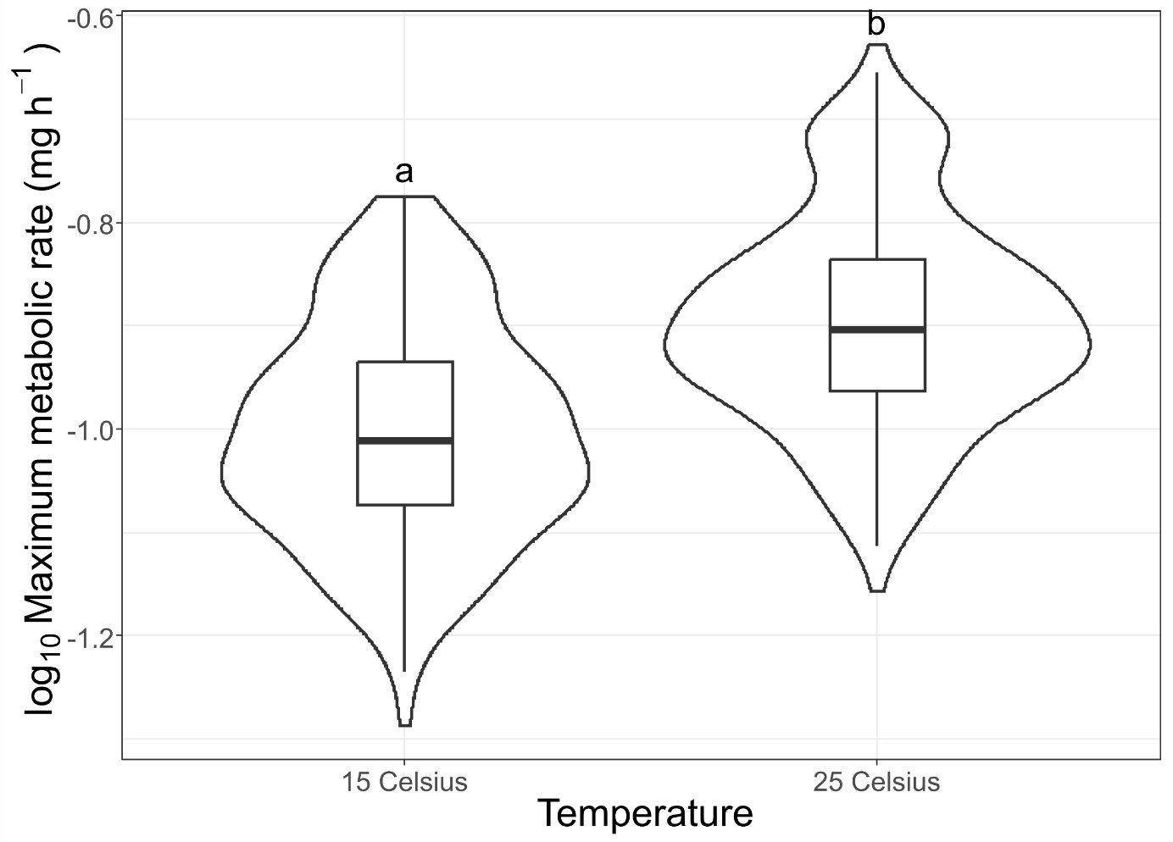

Figure 3. The results of experiment I (field-collected amphipods): Violin boxplot showing maximum metabolic rate (MMR)of *D. villosus* at 15 Celsius vs 25 Celsius (data pooled for both amphipod groups and oxygen conditions)**.** The presented values are model estimates for a significant main effect of Temperature (Table 3). Letters indicate significant differences between the means.

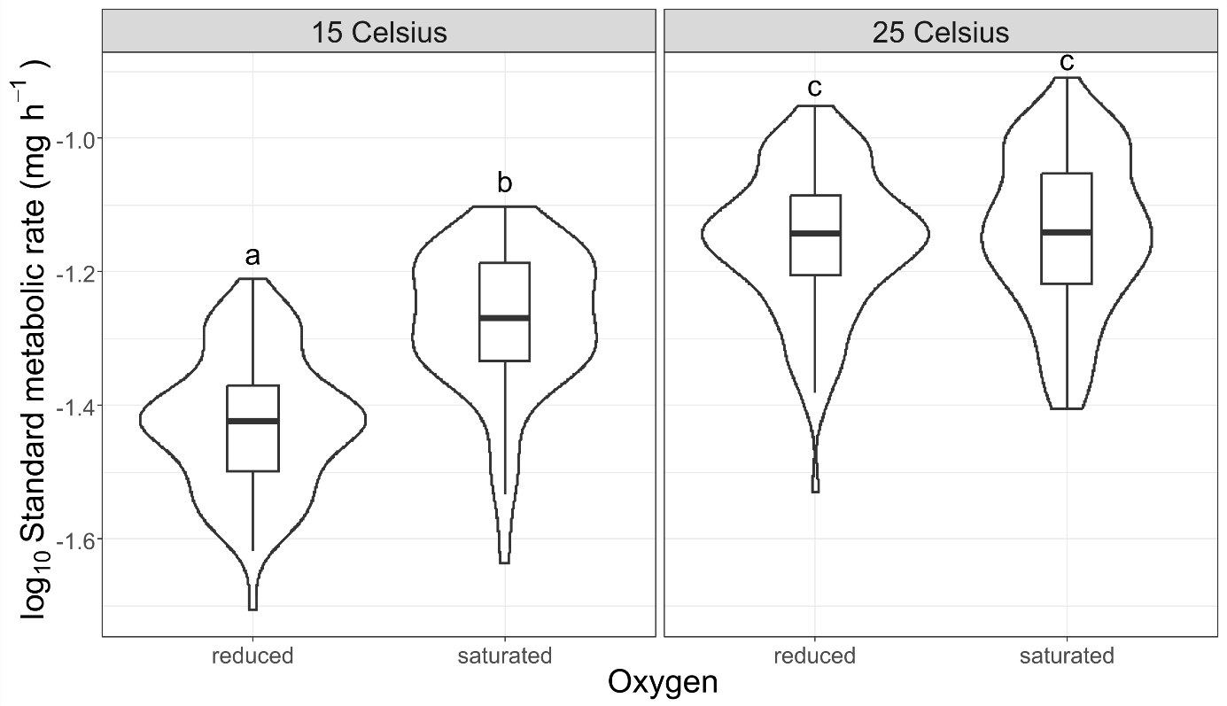

Figure 4. The results of experiment I (field-collected amphipods): Violin box plot showing standard metabolic rate (SMR) of *D. villosus* at saturated vs reduced oxygen conditions at 15 Celsius and 25 Celsius (data pooled for both amphipod groups)**.** The presented values are model estimates for a significant Oxygen x Temperature interaction (Table 3). Letters indicate significant differences between the means.

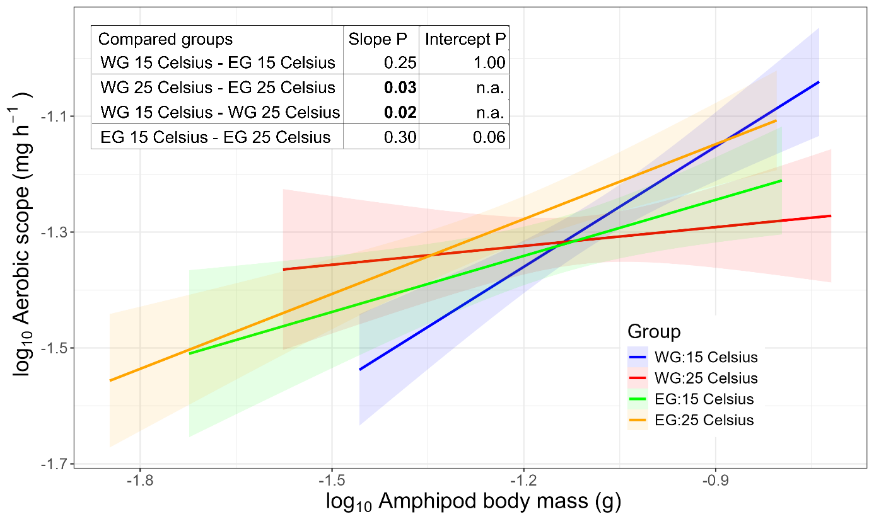

Figure 5. The results of experiment I (field-collected amphipods): Relationship between aerobic scope (AS) and body mass of Western (WG) and Eastern (EG)*D. villosus*groups at 15 Celsius vs 25 Celsius (data pooled for both oxygen conditions**).** Lines represent fits from the linear model, shaded areas correspond to 95% confidence intervals for a significant Amphipod group x Temperature x Body mass interaction (Table 3). The inserted table represents results of LSD pairwise comparisons with sequential Bonferroni corrected p-values. Significant differences in slopes and intercepts (not applicable if slopes are significantly different) are in **bold**.



Figure 6. The results of experiment I (field-collected amphipods): relationship between aerobic scope (AS) and body mass of *D. villosus* at saturated vs reduced oxygen conditions (data pooled for both amphipod groups and temperatures)**.** Lines represent fits from the linear model, shaded areas correspond to 95% confidence intervals for a significant Oxygen x Body mass interaction (Table 3).

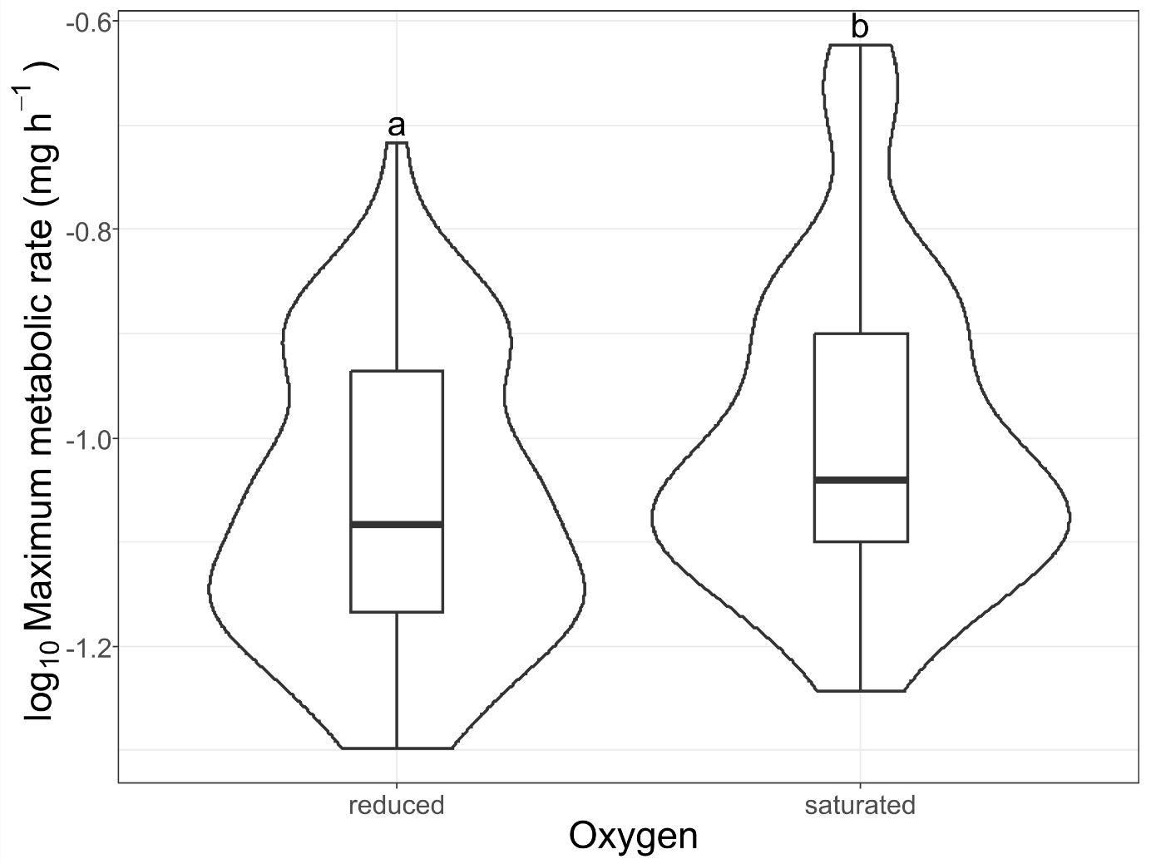

Figure 7. The results of experiment II (F1 generation of amphipods bred in the mesocosm culture): violin box plot showing maximum metabolic rate (MMR) of *D. villosus* at saturated vs reduced oxygen conditions at 15 oC (data pooled for the three experimental treatments: Western and Eastern amphipod groups, and their hybrid)**.** The presented values are model estimates for a significant main effect of Oxygen (Table 4)**.** Letters indicate significant differences between the means.

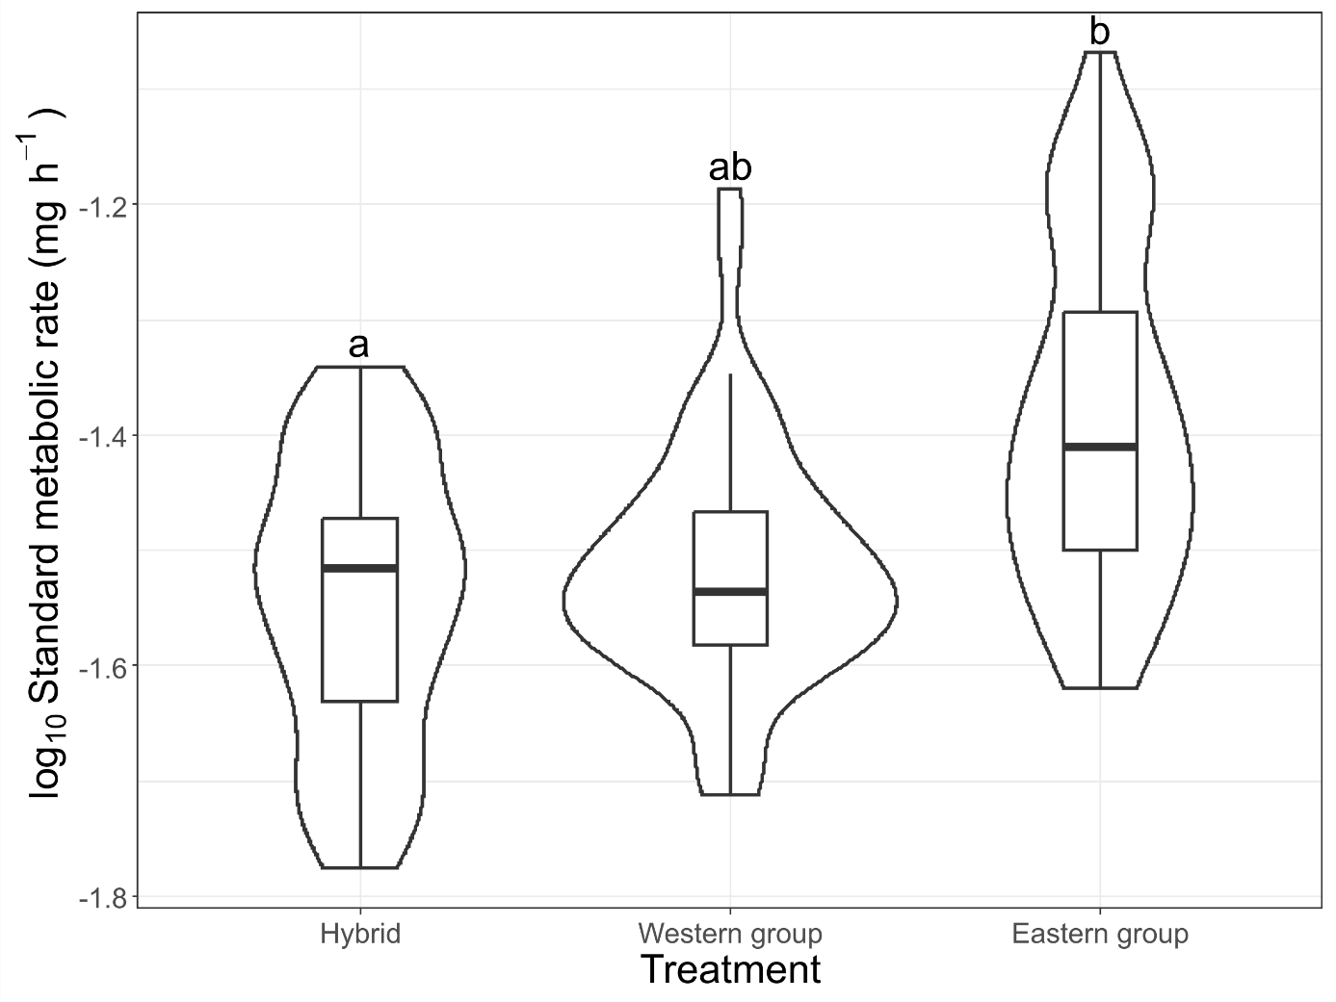

Figure 8. The results of experiment II (F1 generation of amphipods bred in the mesocosm culture): violin box plot showing standard metabolic rate (SMR) ofthree artificially bredgroups of *D. villosus* **(Western group, Eastern group, and their hybrid)** at 15 Celsius **(**data pooled for both oxygen conditions**)**. The presented values are model estimates for a significant main effect of Treatment (Table 4)**.** Letters indicate significant differences between the means.

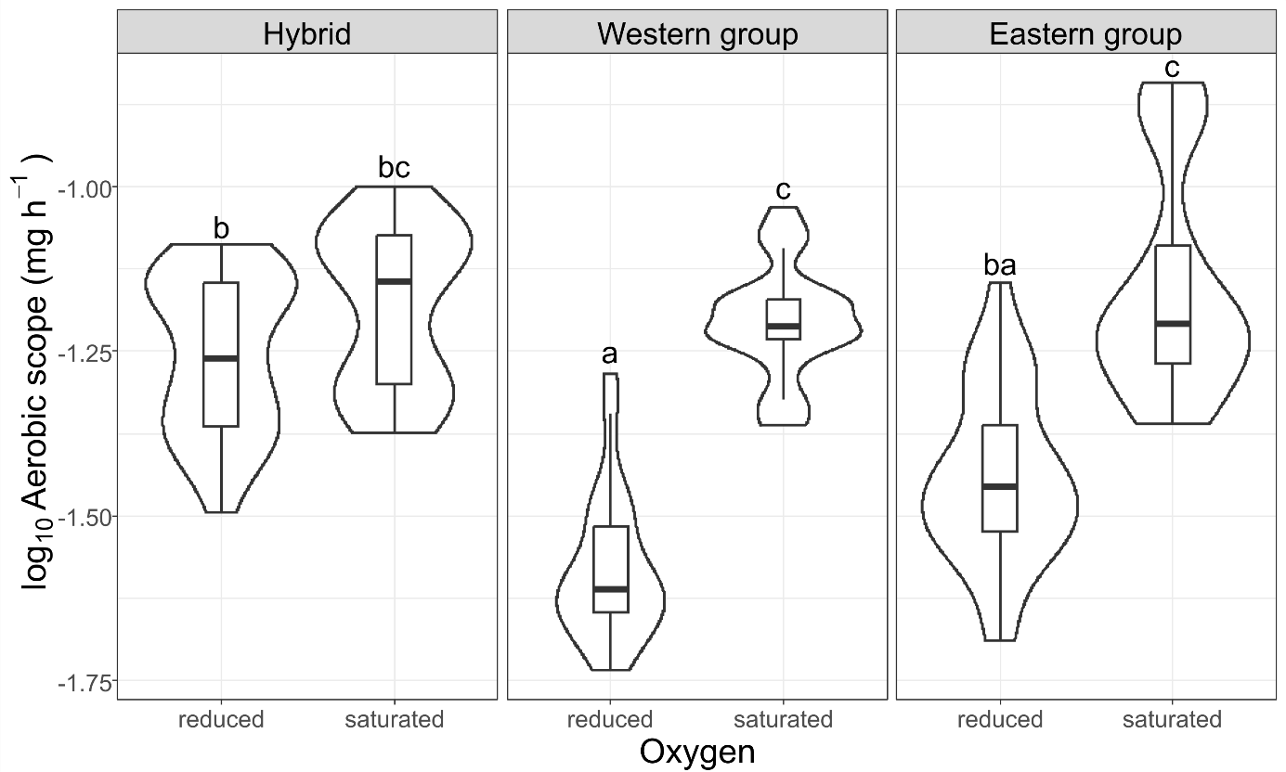

Figure 9. The results of experiment II (F1 generation of amphipods bred in the mesocosm culture): violin box plot showing aerobic scope **(**AS) of three artificially bred groups of *D. villosus* **(Western group, Eastern group, and their hybrid)** at saturated vs reduced oxygen conditions at 15 Celsius**.** The presented values are model estimates for a significant Oxygen x Treatment interaction (Table 4)**.** Letters indicate significant differences between the means.