Appendix S1 Abbreviations

20CRv2c – 20th Century Reanalysis ver. 2. of NOAA and CIRES
AHCCD – Adjusted Historical Canadian Climate Database
ATLR – Atlantic region
BAFR – Baffin Bay region
CANR – Canadian region
CFSR – Climate Forecast System Reanalysis of NCEP
CGW – contemporary global warming
CERA-20C – ECMWF climate reanalysis dataset of the period 1901 to 2010
CIRES – Cooperative Institute for Research in Environmental Sciences (NOAA and University of Colorado, Boulder)
DISC – Data and Information Services Center of NASA
DOE – Department of Energy
GES – Goddard Earth Sciences of NASA
GHCN – Global Historical Climatology Network
GMFD – Global Meteorological Forcing Dataset for Land Surface Modeling
ECMWF – European Centre for Medium-Range Weather Forecasts
ERA-40 – ECMWF 40-year reanalysis
ERA-Int – ECMWF interim reanalysis
ESRL – Earth System Research Laboratory of NOAA
GMAO – Global Modeling and Assimilation Office of NASA
GMFD – Global Meteorological Forcing Dataset for Land Surface Modeling
JMA – Japan Meteorological Agency
JRA-25 – Japanese 25-year Reanalysis
JRA-55 – Japanese 55-year Reanalysis
ICR5 – 5th International Conference on Reanalysis
MERRA – Modern-Era Retrospective Analysis for Research and Applications
MERRA-2 – Modern-Era Retrospective Analysis for Research and Applications version 2
NASA – National Aeronautics and Space Administration
NCAR – National Center for Atmospheric Research
NCEP – National Centers for Environmental Prediction of the NOAA
NCEP-R1 – NCEP-NCAR Reanalysis 1
NCEP-R2 – NCEP-NCAR Reanalysis 2
NH – Northern Hemisphere
NOAA – National Oceanic and Atmospheric Administration
N-PA – Non-polar Amplification
PA – Polar Amplification
PACR – Pacific region
PSD – Physical Science Division of ESRL NOAA
r – correlation coefficient
RA – real (or high) Arctic
RDA – Research Data Archive of NCAR UCAR
RMSE – root mean square error
RRAW – recent rapid Arctic warming
SAT – surface (2m a.g.l.) air temperature
SIBR – Siberian region
SIRTA – Systematic Improvements of Reanalyses in the Arctic
SLP – sea level pressure
SST – sea surface temperature
UCAR – University Corporation for Atmospheric Research

Table S1 Main characteristics of reanalyses used in this study
Dataset (reference) | Class of reanalysis system (Fujiwara et al. 2017) | Source | Full reanalysed period | Spatial resolution
20CRv2c (Compo et al. 2011 | Surface-input | Centre: NOAA CIRES  Download: NOAA ESRL PSD  https://www.esrl.noaa.gov/  psd/data/20thC_Rean/ | 1851–2014 | 2° × 2°
CERA-20C (Laloyaux et al. 2016) | Surface-input | Centre: ECMWF  Download: https://www.ecmwf.int/en/forecasts  /datasets/archive-datasets/  browse-reanalysis-datasets | 1901–2010 | 1.25° × 1.25°
ERA-Int (Dee et al. 2011) | Full-input | Centre: ECMWF  Download: https://www.ecmwf.int/en/forecasts/  datasets/archive-datasets/  browse-reanalysis-datasets | 1979–present | 0.75° × 0.75°
JRA-55 (Kobayashi et al. 2015) | Conventional-input (1958-1978), Full-input (1979–present) | Centre: JMA  Download: NCAR UCAR RDA  https://rda.ucar.edu/  Dataset: 628.1 | 1958–present, 1958–2013 available at RDA | 1.25° × 1.25°
MERRA-2, (Gelaro et al. 2017) | Full-input | Centre: NASA GMAO  Download: GES DISC  https://disc.gsfc.nasa.gov  Dataset: M2IMNXASM | 1980–present | 0.5° × 0.625°
NCEP-CFSR, (Saha et al. 2010) | Full-input | Centre: NOAA/NCEP  Download: NCAR UCAR RDA  https://rda.ucar.edu/  Dataset: 093.2 | 1979–2010 | 5° × 5°  and  2.5° × 2.5°
Explanations: Full-input – assimilation of surface, upper-air conventional and satellite data; Conventional-input – assimilation of surface and upper-air conventional data but not satellite data; Surface-input – assimilation surface data only, with upper-air excluded.

Table S2 Seasonal and annual SAT trends (°C/10 years) in the Arctic. Trends statistically significant at the level 0.05 are shown in bold font

Region | Trends °C/ 10 years
 | 1951–1990 (Przybylak 1996) |  |  |  |  | 1951–1995 (Przybylak 2000) |  |  |  |  | 1951–2000 (Przybylak 2002)
 | DJF | MAM | JJA | SON | YEAR | DJF | MAM | JJA | SON | YEAR | DJF | MAM | JJA | SON | YEAR
ATLR | -0.25 | 0.11 | 0.00 | -0.23 | -0.12 | -0.19 | 0.19 | -0.06 | -0.24 | -0.07 | -0.08 | 0.26 | -0.09 | -0.07 | 0.00
SIBR | 0.15 | 0.10 | -0.10 | -0.14 | -0.01 | 0.15 | 0.15 | -0.17 | -0.04 | 0.04 | 0.06 | 0.10 | 0.04 | -0.03 | 0.04
PACR | 0.53 | 0.12 | 0.12 | -0.14 | 0.15 | 0.55 | 0.31 | 0.36 | -0.02 | 0.31 | 0.38 | 0.41 | 0.29 | 0.15 | 0.33
CANR | 0.02 | -0.35 | -0.04 | -0.13 | -0.13 | -0.06 | -0.11 | 0.02 | 0.00 | -0.03 | 0.13 | 0.16 | 0.12 | 0.24 | 0.17
BAFR | -0.25 | -0.57 | -0.24 | -0.18 | -0.32 | -0.66 | -0.65 | -0.19 | -0.13 | -0.40 | -0.28 | -0.36 | -0.12 | 0.00 | -0.19
HA | -0.06 | -0.08 | -0.04 | -0.18 | -0.10 | -0.10 | 0.04 | 0.01 | -0.12 | -0.04 | 0.04 | 0.15 | 0.04 | 0.06 | 0.08
Region | 1951–2005 (Przybylak 2007) |  |  |  |  | 1951–2010 (Przybylak 2016) |  |  |  |  | 1951–2015
 | DJF | MAM | JJA | SON | YEAR | DJF | MAM | JJA | SON | YEAR | DJF | MAM | JJA | SON | YEAR
ATLR | 0.09 | 0.29 | 0.10 | 0.09 | 0.15 | 0.29 | 0.35 | 0.13 | 0.22 | 0.25 | 0.46 | 0.45 | 0.17 | 0.32 | 0.35
SIBR | 0.12 | 0.29 | 0.04 | 0.17 | 0.16 | 0.24 | 0.34 | 0.10 | 0.39 | 0.27 | 0.31 | 0.48 | 0.15 | 0.50 | 0.36
PACR | 0.45 | 0.46 | 0.25 | 0.26 | 0.35 | 0.44 | 0.35 | 0.25 | 0.42 | 0.37 | 0.48 | 0.37 | 0.26 | 0.45 | 0.39
CANR | 0.16 | 0.12 | 0.14 | 0.30 | 0.18 | 0.35 | 0.26 | 0.20 | 0.41 | 0.31 | 0.41 | 0.25 | 0.23 | 0.44 | 0.34
BAFR | -0.20 | -0.10 | 0.00 | 0.15 | 0.02 | 0.18 | 0.09 | 0.10 | 0.19 | 0.16 | 0.26 | 0.08 | 0.16 | 0.20 | 0.17
HA | 0.16 | 0.21 | 0.12 | 0.20 | 0.18 | 0.32 | 0.29 | 0.17 | 0.33 | 0.28 | 0.38 | 0.33 | 0.19 | 0.38 | 0.32

Table S3 Seasonal and annual standard deviations (°C) of SAT in the Arctic
Area | 1951–2015 |  |  |  |  | 1976–2015 |  |  |  |  | 1996–2015
 | DJF | MAM | JJA | SON | YEAR | DJF | MAM | JJA | SON | YEAR | DJF | MAM | JJA | SON | YEAR
Arctic 1 (HA) | 1.23 | 1.07 | 0.61 | 1.13 | 0.89 | 1.34 | 1.05 | 0.64 | 1.22 | 0.96 | 1.17 | 0.67 | 0.49 | 0.80 | 0.67
Arctic 2 (land+ocean) | 1.07 | 0.93 | 0.54 | 0.77 | 0.68 | 1.09 | 0.82 | 0.57 | 0.75 | 0.63 | 0.94 | 0.69 | 0.43 | 0.45 | 0.53
Arctic 3 (land only) | 1.28 | 1.17 | 0.53 | 1.18 | 0.90 | 1.32 | 1.14 | 0.56 | 1.20 | 0.93 | 1.19 | 0.91 | 0.46 | 0.76 | 0.71
Arctic 4 (land+ocean) | 1.00 | 0.97 | 0.45 | 0.95 | 0.75 | 0.98 | 0.93 | 0.48 | 0.77 | 0.98 | 0.83 | 0.67 | 0.38 | 0.67 | 0.55
Arctic 5 (land only) | 1.06 | 1.03 | 0.51 | 0.92 | 0.76 | 0.98 | 0.94 | 0.55 | 0.96 | 0.75 | 0.75 | 0.72 | 0.43 | 0.60 | 0.52
NH 1 (land+ocean) | 0.34 | 0.33 | 0.31 | 0.34 | 0.31 | 0.31 | 0.31 | 0.31 | 0.35 | 0.30 | 0.20 | 0.18 | 0.17 | 0.22 | 0.17
NH 2 (land+ocean) | 0.36 | 0.36 | 0.30 | 0.37 | 0.34 | 0.33 | 0.34 | 0.30 | 0.38 | 0.33 | 0.20 | 0.19 | 0.17 | 0.24 | 0.18
Key: Arctic 1 – areally averaged temperature based on data from 37 Arctic stations, Arctic 2 – areally averaged temperature for 60–90°N latitude band (HadCRUT4, land + ocean, after Morice et al. 2012, updated), Arctic 3 – areally averaged temperature for 60–90°N latitude band (CRUTEM4, land only, after Jones et al. 2012, updated), Arctic 4 – areally averaged temperature for 60–90°N latitude band (BEST, land + ocean, after Rohde et al. 2013, updated), Arctic 5 – areally averaged temperature for 60–90°N latitude band (BEST, land only, after Rohde et al. 2013, updated), NH 1 (land + ocean) – areally averaged temperature for Northern Hemisphere (HadCRUT4, after Morice et al. 2012, updated), NH 2 (BEST, land + ocean) – areally averaged temperature for Northern Hemisphere (BEST, after Rohde et al. 2013, updated).

Table S4 Differences in seasonal and annual SAT trends (°C decade⁻¹) between individual reanalyses and observations in the Arctic. These differences were obtained by subtracting observational data from reanalysis values

Dataset | 1951–2015 |  |  |  |  | Dataset | 1976–2015
 | DJF | MAM | JJA | SON | Year |  | DJF | MAM | JJA | SON | Year
20CRv2cª | -0.20 | -0.01 | -0.01 | -0.11 | -0.08 | 20CRv2cª | -0.56 | -0.21 | -0.03 | -0.22 | -0.25
CERA-20C^{b} | 0.15 | -0.02 | -0.04 | 0.19 | 0.08 | CERA-20C^{b} | -0.07 | -0.06 | -0.01 | 0.22 | 0.04
JRA-55^{c} | 0.26 | 0.20 | 0.01 | 0.35 | 0.20 | JRA-55^{d} | 0.05 | 0.02 | -0.07 | 0.08 | 0.02
ERA-Int | x | x | x | x | x | ERA-Int | 0.27 | 0.18 | -0.01 | 0.08 | 0.13
MERRA-2 | x | x | x | x | x | MERRA-2 | -0.57 | -0.43 | -0.11 | -0.32 | -0.37
NCEP-CFSR | x | x | x | x | x | NCEP-CFSR^{e} | -0.14 | 0.02 | -0.09 | 0.02 | -0.04
Mean Rean. | 0.05 | 0.04 | 0.02 | 0.11 | 0.06 | Mean Rean. | -0.17 | -0.05 | 0.03 | 0.00 | -0.04
Dataset | 1981–2010 |  |  |  |  | Dataset | 1996–2015
 | DJF | MAM | JJA | SON | Year |  | DJF | MAM | JJA | SON | Year
20CRv2c | -0.56 | -0.22 | 0.00 | -0.20 | -0.24 | 20CRv2cª | -0.05 | -0.27 | -0.02 | -0.01 | -0.08
CERA-20C | 0.00 | -0.10 | 0.02 | 0.21 | 0.04 | CERA-20C^{b} | 0.74 | 0.02 | 0.12 | 1.14 | 0.56
JRA-55 | -0.04 | 0.01 | -0.08 | -0.07 | -0.04 | JRA-55^{d} | 0.25 | -0.10 | -0.07 | 0.12 | 0.06
ERA-Int | 0.23 | 0.27 | -0.06 | 0.02 | 0.12 | ERA-Int | 0.04 | -0.11 | -0.03 | -0.06 | -0.05
MERRA-2 | -0.56 | -0.36 | -0.15 | -0.36 | -0.36 | MERRA-2 | -1.75 | -1.14 | -0.15 | -0.70 | -0.93
NCEP-CFSR | -0.21 | -0.06 | -0.13 | -0.12 | -0.13 | NCEP-CFSR^{b} | 0.36 | 0.08 | 0.19 | 0.51 | 0.32
Mean Rean. | -0.19 | -0.08 | -0.07 | -0.09 | -0.10 | Mean Rean. | -0.22 | -0.12 | 0.25 | 0.12 | 0.01

Key: ª – until 2014, ^{b} – until 2010, ^{c} – 1958–2013, ^{d} – until 2013, ^{e} – 1979–2010

Table S5 Differences in seasonal and annual SAT trends (°C decade⁻¹) between individual reanalyses and observations in the Arctic climatic regions.
These differences were obtained by subtracting observational data from reanalysis values

Region | Dataset | 1951–2015 |  |  |  |  | 1976–2015 |  |  |  |  | 1981–2010 |  |  |  |  | 1996–2015
 |  | DJF | MAM | JJA | SON | Year | DJF | MAM | JJA | SON | Year | DJF | MAM | JJA | SON | Year | DJF | MAM | JJA | SON | Year
ATLR | 20CRv2c | 0.13 | 0.13 | 0.05 | -0.16 | 0.04 | -0.16 | -0.01 | -0.08 | -0.27 | -0.13 | -0.26 | -0.08 | -0.14 | -0.22 | -0.17 | 0.07 | -0.46 | -0.14 | -0.21 | -0.19
 | CERA-20C | 0.06 | 0.01 | 0.04 | 0.13 | 0.06 | -0.08 | -0.18 | -0.03 | 0.02 | -0.08 | 0.05 | 0.02 | 0.00 | 0.14 | 0.05 | 0.94 | -0.22 | 0.20 | 0.28 | 0.23
 | ERA-Int |  |  |  |  |  | -0.08 | 0.01 | -0.12 | -0.02 | -0.03 | -0.05 | -0.03 | -0.24 | -0.11 | -0.11 | -0.07 | -0.11 | -0.09 | -0.16 | -0.11
 | JRA-55 | 0.76 | 0.23 | 0.05 | 0.32 | 0.33 | 0.18 | -0.04 | -0.05 | 0.04 | 0.02 | -0.06 | -0.02 | -0.13 | -0.11 | -0.08 | 0.68 | -0.15 | 0.09 | 0.30 | 0.20
 | MERRA-2 |  |  |  |  |  | -0.46 | -0.43 | -0.17 | -0.22 | -0.33 | -0.43 | -0.33 | -0.26 | -0.30 | -0.33 | -1.18 | -0.88 | -0.10 | -0.52 | -0.66
 | NCEP-CFSR |  |  |  |  |  | -0.37 | -0.25 | -0.24 | -0.19 | -0.25 | -0.24 | -0.19 | -0.29 | -0.16 | -0.23 | 0.41 | -0.80 | 0.08 | -0.12 | -0.19
 | Mean Rean. | 0.21 | 0.14 | 0.07 | 0.08 | 0.13 | -0.03 | 0.01 | -0.04 | -0.02 | -0.02 | -0.17 | -0.11 | -0.18 | -0.13 | -0.14 | -0.10 | -0.02 | 0.17 | 0.17 | 0.06
SIBR | 20CRv2c | -0.01 | 0.08 | 0.03 | -0.06 | 0.00 | -0.57 | -0.01 | 0.03 | -0.24 | -0.19 | -0.57 | 0.00 | 0.06 | -0.29 | -0.20 | -0.42 | -0.60 | -0.17 | 0.00 | -0.28
 | CERA-20C | 0.07 | -0.30 | -0.14 | 0.17 | -0.05 | -0.30 | -0.55 | -0.16 | 0.13 | -0.20 | -0.22 | -0.33 | -0.18 | 0.13 | -0.15 | 0.38 | -0.48 | -0.29 | 1.77 | 0.38
 | ERA-Int |  |  |  |  |  | 0.50 | 0.82 | 0.02 | 0.22 | 0.40 | 0.90 | 1.07 | -0.05 | 0.20 | 0.53 | 0.05 | 0.01 | -0.12 | -0.12 | -0.05
 | JRA-55 | 0.12 | 0.14 | 0.00 | 0.17 | 0.11 | -0.08 | 0.05 | -0.02 | -0.17 | -0.04 | -0.07 | 0.19 | 0.01 | -0.30 | -0.05 | -0.31 | -0.20 | -0.08 | 0.11 | -0.07
 | MERRA-2 |  |  |  |  |  | -0.91 | -0.41 | -0.15 | -0.62 | -0.53 | -0.35 | -0.09 | -0.14 | -0.54 | -0.29 | -2.58 | -2.01 | -0.56 | -1.37 | -1.65
 | NCEP-CFSR |  |  |  |  |  | -0.42 | -0.06 | 0.00 | 0.02 | -0.08 | -0.10 | 0.16 | -0.06 | -0.05 | -0.02 | 0.13 | 0.01 | 0.09 | 1.08 | 0.35
 | Mean Rean. | 0.10 | 0.03 | 0.01 | 0.12 | 0.05 | -0.15 | 0.06 | 0.05 | -0.04 | -0.01 | -0.07 | 0.17 | -0.06 | -0.14 | -0.03 | -0.48 | -0.37 | 0.06 | 0.00 | -0.19
PACR | 20CRv2c | -0.33 | 0.01 | -0.03 | 0.03 | -0.08 | -0.85 | -0.29 | 0.08 | 0.03 | -0.24 | -0.68 | -0.22 | 0.18 | 0.11 | -0.13 | -0.20 | -0.18 | 0.04 | 0.24 | 0.02
 | CERA-20C | 0.08 | -0.05 | 0.00 | 0.29 | 0.08 | -0.39 | 0.01 | 0.05 | 0.62 | 0.09 | -0.11 | 0.00 | 0.11 | 0.61 | 0.17 | 0.00 | -0.78 | 0.19 | 2.17 | 0.46
 | ERA-Int | -0.52 | 0.04 | -0.05 | 0.54 | 0.01 | 0.20 | -0.10 | 0.11 | 0.34 | 0.12 | 0.22 | 0.18 | 0.07 | 0.14 | 0.16 | 0.12 | -0.14 | 0.03 | 0.26 | 0.07
 | JRA-55 |  |  |  |  |  | -0.72 | -0.17 | -0.13 | 0.32 | -0.15 | -0.45 | -0.15 | -0.05 | 0.17 | -0.11 | -1.10 | -0.44 | -0.16 | 0.01 | -0.33
 | MERRA-2 |  |  |  |  |  | -0.47 | -0.33 | 0.14 | 0.23 | -0.09 | -0.38 | -0.15 | 0.03 | 0.00 | -0.12 | -0.83 | -0.24 | 0.20 | -0.03 | -0.22
 | NCEP-CFSR |  |  |  |  |  | -0.49 | -0.08 | 0.28 | 0.45 | 0.01 | -0.26 | 0.09 | 0.21 | 0.10 | 0.05 | -0.42 | -0.60 | 0.64 | 0.93 | 0.15
 | Mean Rean. | -0.08 | 0.03 | 0.03 | 0.25 | 0.05 | -0.33 | -0.05 | 0.14 | 0.28 | 0.02 | -0.28 | -0.04 | 0.09 | 0.19 | 0.00 | 0.04 | 0.17 | 0.45 | 0.48 | 0.30
CANR | 20CRv2c | -0.37 | -0.12 | -0.13 | -0.23 | -0.22 | -0.76 | -0.41 | -0.06 | -0.50 | -0.43 | -0.68 | -0.35 | 0.03 | -0.44 | -0.35 | -0.20 | -0.20 | 0.14 | -0.15 | -0.11
 | CERA-20C | 0.28 | 0.03 | -0.10 | 0.15 | 0.10 | 0.04 | 0.11 | 0.07 | 0.06 | 0.09 | 0.01 | -0.04 | 0.12 | 0.01 | 0.03 | 1.20 | 0.61 | -0.03 | 0.72 | 0.71
 | ERA-Int |  |  |  |  |  | 0.21 | 0.03 | -0.03 | -0.03 | 0.05 | 0.16 | 0.07 | -0.02 | -0.04 | 0.04 | 0.11 | -0.13 | 0.14 | 0.08 | 0.03
 | JRA-55 | 0.03 | 0.03 | 0.01 | 0.26 | 0.07 | 0.08 | -0.06 | 0.05 | 0.08 | 0.03 | -0.08 | -0.11 | 0.00 | -0.07 | -0.06 | 0.88 | -0.01 | 0.17 | 0.34 | 0.30
 | MERRA-2 |  |  |  |  |  | -1.03 | -0.65 | -0.16 | -0.69 | -0.64 | -1.02 | -0.62 | -0.11 | -0.71 | -0.63 | -2.57 | -1.33 | -0.02 | -1.13 | -1.26
 | NCEP-CFSR |  |  |  |  |  | 0.10 | 0.27 | -0.16 | -0.09 | 0.06 | -0.15 | 0.03 | -0.10 | -0.26 | -0.12 | 0.84 | 0.73 | 0.12 | 0.20 | 0.52
 | Mean Rean. | -0.05 | -0.05 | -0.06 | 0.00 | -0.04 | -0.30 | -0.16 | 0.06 | -0.20 | -0.15 | -0.29 | -0.17 | -0.01 | -0.25 | -0.18 | -0.31 | -0.11 | 0.39 | -0.05 | -0.02
BAFR | 20CRv2c | -0.41 | -0.17 | 0.02 | -0.11 | -0.17 | -0.45 | -0.32 | -0.09 | -0.14 | -0.24 | -0.59 | -0.44 | -0.12 | -0.15 | -0.33 | 0.50 | 0.08 | 0.03 | 0.06 | 0.17
 | CERA-20C | 0.24 | 0.21 | 0.02 | 0.23 | 0.19 | 0.35 | 0.30 | 0.04 | 0.29 | 0.29 | 0.27 | -0.17 | 0.05 | 0.15 | 0.09 | 1.19 | 0.95 | 0.55 | 0.73 | 1.03
 | ERA-Int |  |  |  |  |  | 0.51 | 0.14 | -0.03 | -0.13 | 0.08 | -0.06 | 0.03 | -0.05 | -0.07 | -0.04 | -0.01 | -0.18 | -0.13 | -0.36 | -0.19
 | JRA-55 | 0.91 | 0.55 | 0.07 | 0.45 | 0.48 | 0.82 | 0.32 | -0.18 | 0.12 | 0.25 | 0.48 | 0.12 | -0.24 | -0.03 | 0.08 | 1.07 | 0.31 | -0.39 | -0.13 | 0.20
 | MERRA-2 |  |  |  |  |  | 0.00 | -0.34 | -0.22 | -0.32 | -0.27 | -0.62 | -0.61 | -0.27 | -0.27 | -0.46 | -1.59 | -1.24 | -0.26 | -0.47 | -0.89
 | NCEP-CFSR |  |  |  |  |  | 0.47 | 0.20 | -0.32 | -0.09 | 0.05 | -0.31 | -0.40 | -0.41 | -0.23 | -0.34 | 0.81 | 1.08 | 0.04 | 0.48 | 0.76
 | Mean Rean. | 0.08 | 0.07 | 0.06 | 0.11 | 0.08 | -0.01 | -0.10 | -0.03 | -0.02 | -0.04 | -0.14 | -0.24 | -0.17 | -0.10 | -0.17 | -0.24 | -0.27 | 0.19 | -0.01 | -0.08
Explanations: for 20CRv2c, CERA20C, NCEP-CFSR, JRA-55 trends and differences were calculated until 2014, 2010, 2010 and 2013 respectively, except the 1981–2010 column.
Moreover, trends and differences for JRA-55 in the 1951–2015 column were calculated for the period 1958–2013 only.
For NCEP-CFSR, trends and differences in the columns 1951–2015 and 1976–2015 were calculated for the period 1979–2010 only.

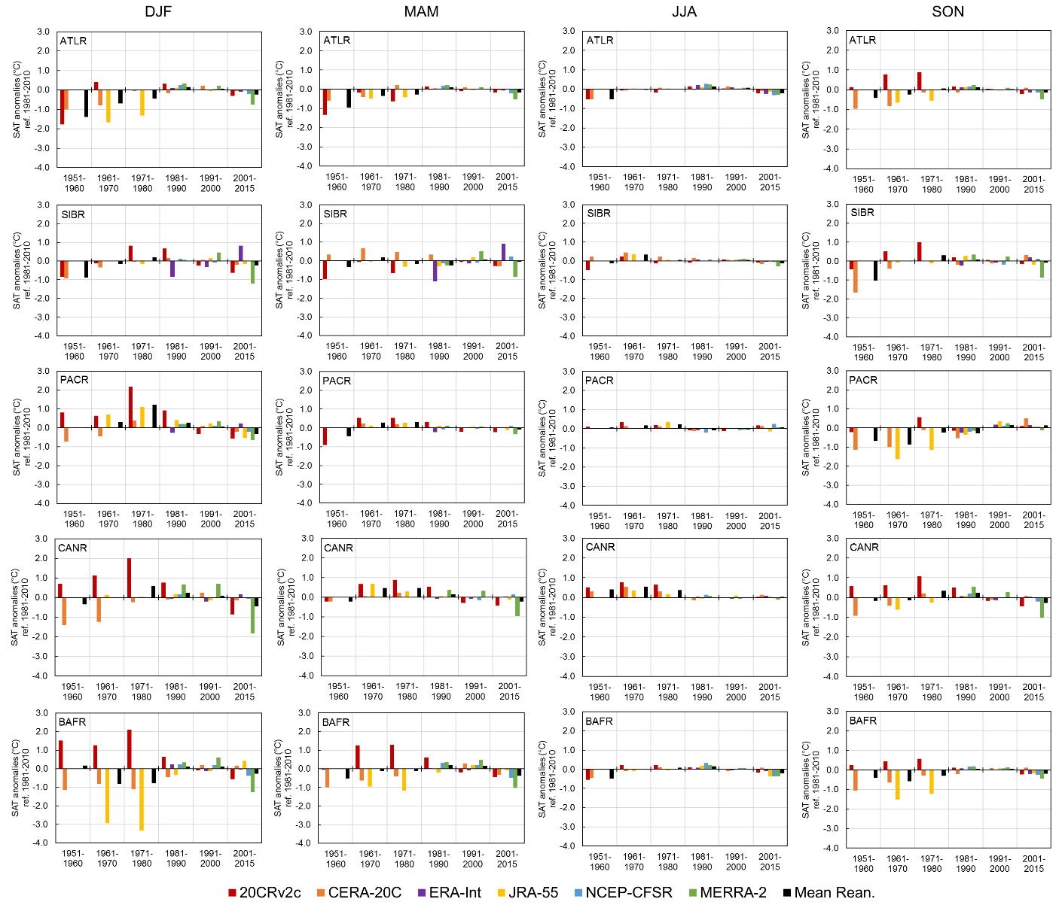
Fig. S1 Decadal differences in seasonal SAT anomalies (°C, relative to 1981–2010 mean) between observations and reanalyses in the Arctic regions in 1951–2015. These differences were obtained by subtracting observational data from reanalysis values. Note that the last period includes a 15-year mean
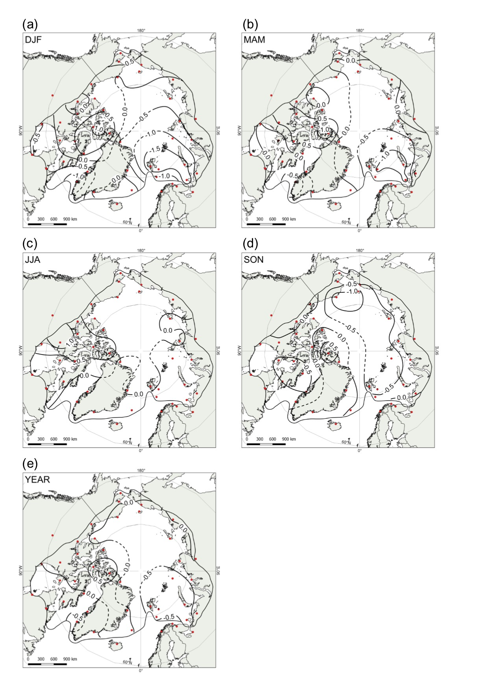
Fig. S2 Spatial distribution of (a–d) seasonal and (e) annual differences between mean reanalysis and observations in 1951–1978. These differences were obtained by subtracting observational data from mean reanalysis values
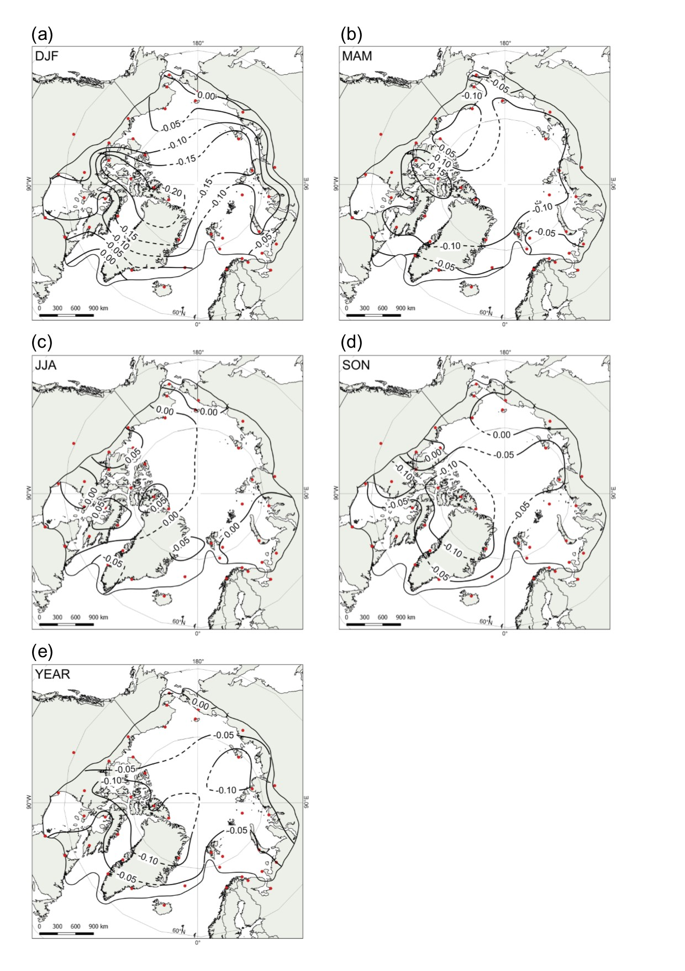
Fig. S3 Spatial distribution of (a–d) seasonal and (e) annual differences between mean reanalysis and observations in 1979–2015. These differences were obtained by subtracting observational data from mean reanalysis values

